Carla Frias

June 2015

Mr. Buck

School Code: 0682

**Tambopata Research Lab**

*Measuring the effects of light intensity on species richness on ground level in the Refugio Amazona.*

During this lab I measured how the species richness of plants found on the Tambopata ground varied in dependence of the light intensity and distance from the Refugio Amazona lodge. A light intensity probe was utilized to measure the amount of light that the plants under the 0.25x0.25m quadrat received as well as a metric tape to measure the distance from the lodge. The lab demonstrated that there was a relationship between species richness and the distance from the lodge and the light intensity.

**Criterion 1: Personal Engagement**

The Peruvian jungle is an environment in which abiotic and biotic factors influence one another in dependence on the way they adapt and interact with their surroundings. Furthermore, the research question ‘What is the effect that light intensity from Refugio Amazona towards the inside of the rainforest (m) have on ground level species richness?’ then reached my interest on discovering if light intensity had an impact on the amount of plants found on ground level. Thereby, the relationship between abiotic and biotic factors would be revealed by the results obtained from this lab.

During this lab, I was able to compare the species richness close from the lodge and 50 meters inside the rainforest by using a metric tape as a guide of measurement. I also utilized a light intensity probe, which varied on the canopy levels and complex community that had developed over time. This let me gain experience on how to conduct a line transect and quadrat study as well as obtain information on plant’s adapting to their conditions and the way this impact the overall biodiversity found in Tambopata. Moreover, this will allow me to gain profound information on the biodiversity that Peru offers and its unique nature.

Figure 1: Representation of Data Collection

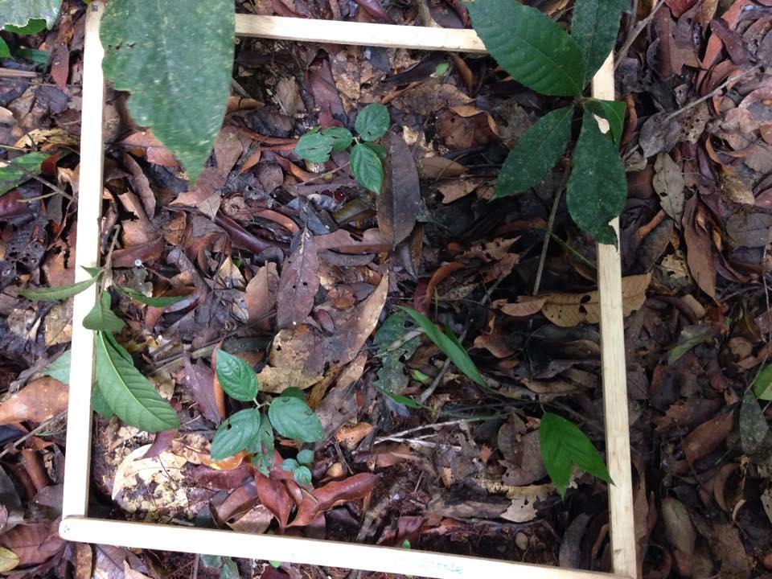

A quadrat sample measured when conducting the experiment along the borders of the trail 30 meters inside of the Tambopata Rainforest.

**Criterion 2: Exploration**

**Research Question:** What is the effect that light intensity from Refugio Amazona towards the inside of the rainforest (m) have on ground level species richness?

**Background Info:**

Plant canopies are the biggest trees in the rainforest, making them the tallest layer. Moreover, as the sun releases light levels to the rainforest, the amount that is received to the bottom plants in the forest floor depends on the amount of shade or well-lit clearings that is has. Nevertheless, plants in the forest floor adapt to their lowering light condition yet limit their ability to undergo photosynthesis and overall growth as a plant, causing species to be limited to several factors, one of them being light

Additionally, human interference also plays a big role on plants and the way they develop. Because all plants have a fundamental niche, their surroundings plays a big role on deciding the size of the niche (or if they become realized). Nevertheless, as the Refugio Amazona was built, the soil pH/salinity, light intensity, water availability, energy availability, among other abiotic factors,3 influenced the way plants survived, causing the environment to be a very hard area to study without the control of variables. However, the interaction of humans to nature can cause the limitation of a greater amount plants being able to survive based on the conditions, which favor plants rather than limit them. The zone of stress for plants to survive can be then manipulated by both light intensity limited by canopy trees as well as the human’s interactions to control their surroundings and overall possible adaptability in order to survive.

Nevertheless, not only does human interference and light intensity affect the species richness found on ground level at Refugio Amazonas, but other additional variables such as the soil pH, soil salinity, water availability, competition levels, etc. Such factors affect the surroundings in which plants have to adapt to, causing species richness to depend on their overall environment and not just on light intensity.

**Table 1: Variables through out the conduction of the Lab**

|  |  |  |  |
| --- | --- | --- | --- |
| **Variable Type** | **Variable** | **Unit & Uncertainty** | **How are variables manipulated?** |
| **IV** | -Light intensity  -Distance from the lodge | -lux ±.0.2  -m | The amount of light intensity varies in dependence of how deep inside you are in the rainforest. The canopy trees limit the amount of light that reaches the forest floor plants.  -A metric tape is used to measure the distance from the lodge to the inside of the rainforest |
| **DV** | -Species | D | The Menhinick’s index is used to calculate the species richness per quadrat measured |
| **CV** | -Quadrat size  -Time of the day investigation is conducted | 1x1m |  |

Other variables that affected by lab but could not kept in control due to the study being made in the field where: soil moisture, soil pH, humidity, temperature.

**Table 2: Materials utilized when following the procedure for the lab**

|  |  |  |  |
| --- | --- | --- | --- |
| Item | Quant. used | Size | Units of measurement |
| Metric Tape | 2 | 60 meters | Meters |
| Quadrat | 1 | 1x1 | Meters |
| Light intensity probe | 1 | - | lux |

Methods of Data Collection:

When collecting data, a Metric Tape from the lodge was set on the field of study in order to measure the distance from the lodge to the inside of the rainforest. When conducting the lab I realized that a trail had been made by the lodge, thus it had impacted the variety of plants that where in such location. With that, I decided that the field of study where the quadrat will be placed in order to measure plant diversity will be based on 5 trials in which each was 2 meters inside of the rainforest. The line transect was then based on meters from the lodge to the inside of the rainforest following the trail, and from the trail 2 meters inside the rainforest to the left.

Additionally, a Lux Meter was placed at ground level in the center of each quadrat at mid-day (12:30 pm) on a cloud free day in May. This would allow me to obtain the light intensity that the plants in the quadrat where receiving.

*Procedure:*

|  |  |  |  |  |  |  |  |  |  |  |  |  |  |  |  |
| --- | --- | --- | --- | --- | --- | --- | --- | --- | --- | --- | --- | --- | --- | --- | --- |
| Table 3: Estimating the effects that light intensity has on plant diversity in relation to it's distance from the Refugio Amazona Lodge | | | | | | | | | | | | | | | |
| Distance away from the lodge | Light Intensity | | | | | # of species | | | | | Total # of organisms | | | | |
| Trials | | | | | Trials | | | | | Trials | | | | |
| Trial 1 | Trial 2 | Trial 3 | Trial 4 | Trial 5 | Trial 1 | Trial 2 | Trial 3 | Trial 4 | Trial 5 | Trial 1 | Trial 2 | Trial 3 | Trial 4 | Trial 5 |
| 0 | 232 | 862 | 864 | 875 | 889 | 0 | 3 | 2 | 3 | 2 | 250 | 321 | 398 | 270 | 260 |
| 10 | 854 | 874 | 853 | 879 | 886 | 4 | 3 | 2 | 2 | 3 | 268 | 296 | 314 | 276 | 298 |
| 20 | 956 | 856 | 921 | 897 | 912 | 2 | 1 | 4 | 4 | 3 | 8 | 14 | 26 | 32 | 36 |
| 30 | 432 | 332 | 574 | 498 | 510 | 3 | 2 | 3 | 4 | 3 | 7 | 9 | 16 | 22 | 12 |
| 40 | 137 | 65 | 89 | 104 | 98 | 3 | 2 | 1 | 2 | 2 | 5 | 14 | 21 | 18 | 34 |
| 50 | 975 | 956 | 432 | 456 | 398 | 1 | 2 | 1 | 2 | 1 | 1 | 7 | 14 | 9 | 12 |
| All data was collected at a temperature of 24 C by Carla Frias on May 22. A line transect was utilized from the Refugio Amazona Lodge to the inside of the Rainforest. A second line transect was then applied to obtain different trials in which human interference did not impact the results and greater reliability could be obtained. A quadrat was used to obtain the # of species and total # of organisms in order to obtain specie richness as well as a light intensity probe placed on the middle of the quadrat to obtain the amount of LUX that the plants recieved. Other variables which may have altered data and where not controlled are: soil moisture, soil pH, humidity, temperature. | | | | | | | | | | | | | | | |
|
|
|
|
|

1. The first metric tape was placed on the Refugio Amazonas edge of its floor looking towards the inside of the rainforest
2. A quadrat was placed on the beginning of the metric tape
3. The Light Intensity probe was introduced to the middle of the quadrat and results where recorded
4. The amount of plants in the quadrat where counted and recorded
5. A second metric tape was placed looking towards the left of the rainforest.
6. A quadrat was placed two meters away from the beginning of the metric tape
7. Step 3 & 4 where repeated
8. Step 6 & 7 where repeated 4, 6, 8, 10 meters away from the beginning of the metric tape
9. Steps 2-8 where repeated 10, 20, 30, 40 and 50 meters away from the beginning of the first metric tape

***Refer to Apendix A***

**Criterion 3: Analysis**

**Table 3: Raw Data Table**

**Safety, Environmental & Ethical Considerations**

* When conducting this lab I had to be careful I did not step on any of the plants on the floor in order to avoid greater disturbance to nature
* I had to be careful with the trees I touched to avoid any insects or harmful organisms to climb my body and cause any harm
* A responsible adult came with me to conduct this lab to use their guidelines on location as well as a proper use of materials

**Table 4:Processed Data Table**

|  |  |  |  |  |  |  |  |  |  |  |  |  |  |
| --- | --- | --- | --- | --- | --- | --- | --- | --- | --- | --- | --- | --- | --- |
| Table 4: The effects the light intensity has on plant diversity at the Tambopata Refugio Amazona's area | | | | | | | | | | | | | |
| Distance away from the lodge | Light Intensity (LUX) | | | | | | Species Richness | | | | | | |
| Trials | | | | | Average | Trials | | | | | Average | Standard Deviation |
| Trial 1 | Trial 2 | Trial 3 | Trial 4 | Trial 5 | Trial 1 | Trial 2 | Trial 3 | Trial 4 | Trial 5 |
| 0 | 232 | 862 | 864 | 875 | 889 | 744.4 | 0.13 | 0.10 | 0.07 | 0.10 | 0.07 | 0.09 | 0.03 |
| 10 | 854 | 874 | 853 | 879 | 886 | 869.2 | 0.24 | 0.17 | 0.11 | 0.12 | 0.17 | 0.17 | 0.05 |
| 20 | 956 | 856 | 921 | 897 | 912 | 908.4 | 0.71 | 0.27 | 0.78 | 0.71 | 0.50 | 0.59 | 0.21 |
| 30 | 432 | 332 | 574 | 498 | 510 | 469.2 | 1.13 | 0.67 | 0.75 | 0.85 | 0.87 | 0.85 | 0.18 |
| 40 | 137 | 65 | 89 | 104 | 98 | 98.6 | 1.34 | 0.53 | 0.22 | 0.47 | 0.34 | 0.58 | 0.44 |
| 50 | 975 | 956 | 432 | 456 | 398 | 643.4 | 2.00 | 4.65 | 4.74 | 5.00 | 4.46 | 4.17 | 1.23 |
| All data was collected at a temperature of 24 C by Carla Frias on May 22. Spechies Richness was obtained by dividing the # of species over the total # of organisms in the quadrat in which the study was conducted. Through the data, we noticed that human interferance impacted immensly the plant diversity due to the manipulation of nature. This may explain the inconsistency of plant diversity as well as light intensity as we moved deeper inside the rainforest. Adittionally, canopy layers are altered due to succession and other natural disasters which impacts light intensity and (may) alter plant diversity. | | | | | | | | | | | | | |
|
|
|
|

**Sample Calculations/Data Processing**

Menhinick’s index - Species richness

D=s/√N S=# of different species

N=total # of individuals per sample

*Example:*

Distance Away: 10 – Trial2: 3/√296 = 0.17

*Graph #1: The effects that Light Intensity has on the species richness at ground level*

*Graph #2:* The effects that the distance from the lodge has on species richness

*Trend:* While graph #1 shows a trend line that the higher the light intensity the lowers the species richness, graph #2 shows that the further away the distance from the lodge, or the greater the light intensity the more species richness there will be. Graph #1 also shows an where there is light intensity of 600 lux and species richness of 4.0.

**Criterion 4: Evaluation**

Graph #1 outlines that as light intensity increases, so does the species richness. Yet by taking a look at Table #2, when light intensity increases to 908.4 lux the species richness is of 0.59, yet when light increases decreases to 469.2, spices richness increases to 0.85. However, when taking a look at Graph #2, you can see that as the distance away from the lodge increases, so does the richness of species of plants found in ground level. Therefore, the inconsistency of the values on Table # 2 defined by the trend in which the higher the light intensity the higher the species richness portrays the dependence that plant diversity has on its surroundings and its overall abiotic factor rather than on one simple abiotic factor, in this case light intensity. Its niche in which the plant is adapting to depends on several elements which allow plants to survive. Due to the data being collected from the lodge towards the inside, the major impact was the human interference. We noticed that when the light intensity high, 869.2 lux, the quadrat was measured in an area where there was no canopy and had been artificially planted by the lodge, reducing its species richness to 0.17. On the other hand, as light intensity began to decrease, reaching 98.6 lux for example, and the species richness collected was of 0.58, the quadrat measured was inside of the rainforest and away from the lodge, explaining the block of sunlight towards the ground level species as well as its effect.

Other externalities also influenced the data collected. For example, when calculating the trials 50 meters away from the lodge, the rainforest was undergoing secondary succession causing the canopy to be thinner and the light intensity to be direct to the plants, reaching 643.4 lux. On the other hand, small shrubs who where also in the ground level shadowed the area which was being measured, impacting the results and the amount of light that reached the plant.

Moreover, by taking a look at the error bars from Graph #1 and #2, you noticed that they are very wide. This then represents that the data collected is not fully reliable due to the variety of measurements that are varied and dispersed. Therefore, the trend corresponding for both graphs is not precise and is based of speculations based on uncertain data.

The rainforest has had a great variety of taxonomic groups in which the plants found at the ground level fall under. The evolutionary paths allow natural selection to occur in correspondence to their geographical surroundings found within their environment to adapt and survive. Moreover, the number of different taxonomic groups and overall species richness recorded in this lab increased disproportionately in the rainforest because of their influential factors, such as soil ph/salinity, water availability, etc. that where not measured and kept constant through out the lab.

However, one abiotic factor fundamental for plants to survive is light intensity. Light is the power source for photosynthesis; As photosynthesis occur, the energy contained inside the light is absorbed by the plants chloroplast and transforms it into glucose or sugar molecules, essential nutrients for the plants to consume in order to live and survive2. Additionally, as chloroplast absorbs the energy, a pigment material called chlorophyll stimulates its electrons causing its energy to be transformed to a water molecule, split into its component parts and composing oxygen and hydrogen as the n products.

Light intensity then plays a huge role on the characteristics of the environment in which plants adapt to. The rainforest consist of different layers: the tall emergent canopy, several mid-layers, an understory and a ground level. The canopy levels, being composed of the tallest trees, are those who receive direct sunlight thus limit the amount of light reaching the levels that are underneath3. This may then impact variety of plants is limited on ground-dwelling environment since, under such conditions, the survival of plants may be rather difficult due to the limited photosynthesis that can be endured. Therefor, the amount of glucose received in order to survive is vastly reduced. Additionally, the middle strata of the rainforest may show greater diversity than those on the outside, as such investigation was held. This is because emergent trees may be taller, allowing a greater amount of vertical space for other trees and plants to live, increasing diversity.

Furthermore, because the temperature in Tambopata is consistent4, plants do not suffer from low temperature stress and allow them to apply their energies to growth and reproduction at the low light intensity environment that they live in. This may then cause plants, which live under tall canopies with low light intensity to specialize in adapting to their light regimes, causing plant diversity to remain the same yet on a survival key. This may then cause light intensities to, rather than promote richness, enhance survival under such conditions, portraying the ability for plants to adapt to their niche. This may also be referred as ‘adaptive radiation’5 where populations of species of plants became reproductively isolated by adapting to their ecological niche, in this case influenced by the amount of light it receives.

Despite plants not having low temperature stress, the do have a tolerance for light availbility3 which they must not exceed or deceed. This tolerance causes some plants to survive while others to not, limiting the amount of species that are able to survive despite their conditions. Such desire towards light in order to obtain their nutrients causes, not only their fundamental niche to become realized based on the competition created to obtain lights from radiations passed through the canopy trees, but also the amount of species who are able to survive by such condition.

Additionally, human interference also played a huge role on the data collected through out this lab. The data collected was measured from the Refugio Amazona towards the inside of the rainforest and the trails where measured from the trail created by the lodge towards the left inside of the rainforest, having human interference as a variable. Human interference had a huge impact on the data because of the fact that the Refugio had planted fake grass on the first 3 meters that where measured for each trial, limiting the specie richness to the decision that the Refugio took to plant rather than naturally. This might then explain why there is such a low species richness close the lodge (0.17) rather than when inside of the rainforest.

**Table 5: Experimental Error**

|  |  |  |
| --- | --- | --- |
| **Experimental Error** | **Effect on data collected** | **Improvement to design** |
| The soil moisture, soil pH, humidity, temperature was not controlled | This may have altered the way plants adapt to their surroundings rather than basing the investigation on one single abiotic factor which varies and depends on other abiotic factors | Keep track of externalities which may have direct/indirect impact on lab just for extra information |
| Area used had a trails made by the lodge | Because there was a trail, the plants which surrounded the area in which the study was conducted had been altered immensely by human interference causing data to depend on how far from the trail the information was recorded | Use the wilderness and surroundings of the area to obtain accurate data |
| Not so many samples where measured | This made my conclusions vague since they where based off limited reliability results. | “The more the better” – more results would not have negatively impacted my results but allow the conclusions to be based off of factual data of data recorded. Next time I will try to obtain more results rather than less since we there is never a limit to how much information one can have |
| Different areas of the rainforest where not measured | This may have allowed the relationship between species richness and their surroundings to be based off different environments and thus give more reliability and data to my conclusions and investigation | Try to exceed on what I am trying to achieve. Never set myself for low bars, do previous investigations on what extra information can be gained to try to squeeze all the information possible. |

**Appendix**

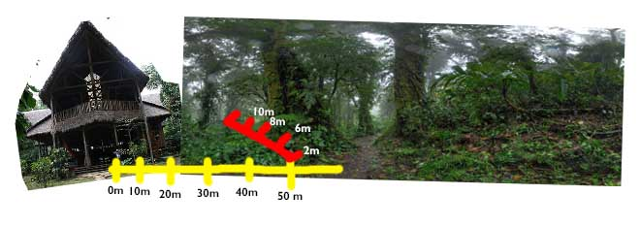

**A- Trials & Procedure**

This is a visual representation of how the lab was conducted. The yellow lines dash represent the quadrats tested from the lodge towards the inside of the rainforest. For each quadrat tested, 5 trails where made from the position where you are standing towards the inside of the rainforest for 2,4,6 and 8 meters.

**Criterion 5: Communication**

1. "D. Why is there so much biodiversity in tropical rainforests?" *Rainforest Conservation Fund*. N.p., n.d. Web. 31 May 2015. <http://www.rainforestconservation.org/rainforest-primer/2-biodiversity/d-why-is-there-so-much-biodiversity-in-tropical-rainforests/>.
2. "The Effect of Light Intensity on Plant Growth." *eHow*. N.p., n.d. Web. 31 May 2015. <http://www.ehow.com/about_6671823_effect-light-intensity-plant-growth.html>.
3. "The human impact on biological diversity. How species adapt to urban challenges sheds light on evolution and provides clues about conservation." *EMBO Reports*. PMS: US National Library of Medicine, n.d. Web. 3 June 2015. <http://www.ncbi.nlm.nih.gov/pmc/articles/PMC1852758/>.
4. "Foilar Temperature Tolerance of temperate or tropical evergreen rainforest   
        trees of Australia." *Oxford Journals*. N.p., n.d. Web. 20 June 2015.   
        <http://treephys.oxfordjournals.org/content/26/11/1435.full.pdf>.
5. "Triggering Adaptive Radiation." *Understanding Evolution*. N.p., n.d. Web. 20   
        June 2015. <http://evolution.berkeley.edu/evosite/evo101/   
        VIIB1aAdaptiveRadiation.shtml>.