Modeling absorption using Dialysis Tubing Lab
Background: Dialysis tubing contains small pores that allow some substances to pass in and out of the blood depending on their molecular sizes and concentrations. In this lab, you will see that some materials can move through the tubing while others cannot. This is analogous to selective absorption occurring in small intestine except that the small intestine uses both passive and active processes to absorb nutrients.
Materials:
- 1 15cm piece of dialysis tubing
- Test Beaker (T)
- Wash Beaker (W)
- Iodine solution
- Bottle of unknown solution A
- Bottle of unknown solution B
- Bottle of unknown solution C
- well plates
- test tube rack with test tubes
- Cup/beaker for water
- Goggles
- Benedict's Solution
- Hot water bath/Boiling Water
- 10ml graduated cylinder
Procedure:
- Starch Test
  - Shake bottles A, B, and C before starting.
  - Place a couple drops of solution A into cavity 1. Place a couple drops of solution B into cavity 2. Place a couple drops of solution C into cavity 3.
  - Add a drop of iodine to each cavity and refer to the table below.
Solution A = Starch
Solution B =
Solution C =
Solution | Iodine | Benedict’s
Starch | Blue-black | No indicator change
Glucose | No indicator change | Green/yellow/orange/red/brown
Water | No indicator change | No indicator change

2. Glucose Test
  - Shake bottles A, B, and C before starting.
  - Place a couple drops of solution A into test tube 1. Place a couple drops of solution B into test tube 2. Place a couple drops of solution C into test tube 3.
  - Add a few drops of Benedict’s solution to each tube and place in water bath set to 80℃+. Color change to green, yellow, orange, red indicates reducing sugar.

On the basis of your results, what are unknown solutions A, B, and C?
Unknown A = Starch
Unknown B = Glucose
Unknown C = Water
- Glucose goes out
- Starch stays in

Testing for diffusion across a semipermeable membrane
  - Follow all directions/steps in the order shown. Record all observations, results and answers to questions as directed. Notify teacher of spills or problems immediately.
  - Label one cup with a ‘T’ for TEST and the other with a ‘W’ for WASH, if it has not been done for you.
  - Fill the WASH cup half full with water.
  - Soak the dialysis material (which looks like a flat piece of plastic) in the WASH cup and wait about 30 seconds until the tubing is soft. Be careful with tubing, to prevent tears.
  - At this time the flat piece of plastic (or dialysis tubing) will open into a tube when gently rubbed between two fingers (again, be gentle to prevent tears). Remove it from the water and continue to wet and rub it until the tube is open.
  - Very close to the end, twist the tube and tightly tie a knot as close to one end as possible.
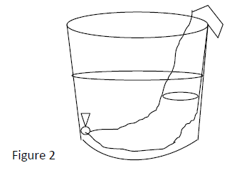
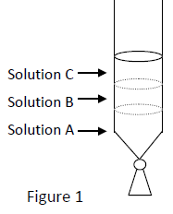
  - Fill the dialysis bag with approximately equal portions of solution A; solution B; and solution C until the bag is no more than one-half full (you don’t need more than approximately 5 mL of each solution). See Figure 1.
  - Pinching the open end closed, carefully dip the bag in the WASH cup. Rinse the outside of the bag over the WASH cup with clean water from the cup provided at your lab station.
  - Place the one-half full dialysis bag in the TEST cup so that the open end is securely draped over the edge of the cup. See Figure 2.
  - Fill the TEST cup to about 3⁄4 full of clean water so that the water covers about 3⁄4 of the bag. Use caution to prevent the open end of the bag from slipping into the TEST cup.
  - Leave the dialysis bag soaking in the cup for 5-10 minutes. The questions below can be answered after the 5-10 minute wait period.
  - Add about 30 drops of iodine into the TEST cup.
  - Test for glucose by removing a sample of water from test cup and testing sample with Benedict’s.

Clean-Up
- Rinse the cups, beakers, graduated cylinders and all other equipment.
- Throw away used dialysis bags, paper towels, and test strips.
- Return equipment to original position
- Wipe up any and all spills, and your lab bench using paper towels.

Analysis
- You know the inside of your dialysis bag contains glucose. Did glucose exit? Explain how you know this.
Yes - because there was glucos inside of the bag and pure water outside, the concentration was bigger inside. This meant that water would move inside the water as the concentration gradient was greater inside than outside, causing glucose to exist due to their inability to dissociate in water. This was proven when the strip turned brown once applied to the water.

- You know the water in the cup contains iodine. Did iodine enter the bag? Explain how you know this.
Yes- I knew this because the solution inside of the dialysis bag turned blue after a couple of minutes, proving that iodine had entered the bag through the net movement down the concentration gradient to react with the starch inside it.

- You know the inside of your dialysis bag contains starch. Did starch exit? Explain how you know this.
No- I knew this because when I tested the bag with iodine solution, the bag did not turned dark blue, proving that it did not have any reaction with starch because they where the same solution.

- A patient is being treated with a kidney dialysis machine. The diagram below represents the patient’s blood flow through the kidney dialysis machine. People who suffer from kidney failure have toxins accumulate in their blood because their kidneys are not filtering their blood properly. If their blood is not cleansed, they will likely die.

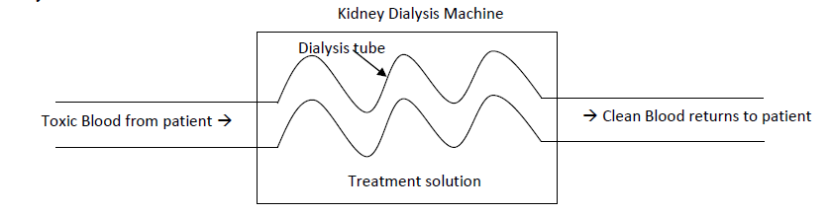

You are a technician. Using what you learned from performing this task and your knowledge of biology and diffusion, describe how the process of dialysis cleans a person’s blood.

When people’s kidneys stop working, they can no longer break down wastes that someone may have in their bloodstream, causing health problems and lead to diseases such as anemia. Doctors then go through the medical treatment of dialysis, where they are in charge of filtering the blood in your body and eliminate all the waste. There are two different types
- Hemodialysis: the patient's blood travels through inserted tubes to a dialyzer, a machine in charge of removing waste and extrafluid from your body. Once the dialyzer completes its job, the blood is sent back to the body through another tube.
- Cyclic dialysis: a cleansing solution called dialysate is inserted through the person's belly 8-12 times a night. Through such, the blood that passes through the blood vessels undergo filtration of the blood and dialysate from the belly. This causes waste to be removed and rebalanced of blood waste in the huma body.

