Impossible, Imaginary, Useful
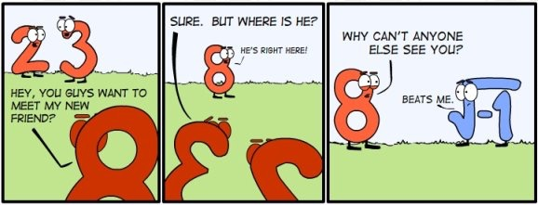
Carla Frias
Knowledge Question:To what extent are models a reliable source to gain new knowledge?

Claim:
Knowledge can be shaped as a representation model to perceive information in an applicable manners. This means that data can be entitled through model configurations where solutions can be found through a reasoned thought process, thus avoid mistakes or misleads. For example, Rafael Bombelli, a famous mathematician, tried to find the solution for negative square root numbers. Through his process, he tested, compared and evaluated the results of different numbers to shape a model based on trends and common processes. Moreover, Bombelli was able to come with a universal tool, as well as a set of rules, for negative square root numbers wishing to be simplified as one solution by a test and trial method.. Up until know, his model is applied world wide when studying numbers and its possibilities. Thereafter, models can open the gates to unearthing discovers which where never proven before. The facilitated search of a solution can be reduced to a single model which succeeds on its indicated purpose depending on its area of knowledge, allowing a greater inheritance of knowledge.

Counterclaim:
Models are prone to changes, meaning that knowledge can never be set on a single most defined answer, limiting the extent to which we rely on the information we gather. The dependence on the imagination applied when coming up with a model can affect the results being acquired. This means that we limit the possibilities to solutions because of the way we decide to build up a representation of knowledge. For example, when several mathematicians such as Rafael Bombelli and Girolamo where seeking for ways to represent the square root of the negative number, they found out that some numbers where simply impossible to be found as a single defined solution. This meant that numbers such as the square root of negative one where simply nothing more or nothing less, meaning imaginary or impossible. Moreover, if we are able to produce with our imagination a model to represent the solution of other square roots of a negative number such as ‘1 + square root of negative121’, then why are we not allowed to shape one for the square root of negative one? The unlimited models left to be discovered in the nature of earth relies on our imagination to be applied with out reasoning, raising intrigues as to why hasn’t a solution for such number not be found yet. We have acquired knowledge through a represented model, but to what extent is that model the only one to be used to find a solution?

Nevertheless, although they may never be a defined solution to a problem, a model can be used to represent data in a more simplistic way. This means that the thought process through a test and trial method to prove the validity on one possible solution can cause models to be used to shape our knowledge in ways that can be compared to other solutions. If the same model is a applied to search for the same answer, then we can allow its solutions to fit its desired aim to accept knowledge as it currently is.

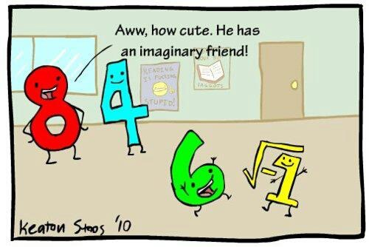
One more joke….

