**Heart Dissection Questions!!**

Label the diagram of the human heart below. Add labels to Table below.

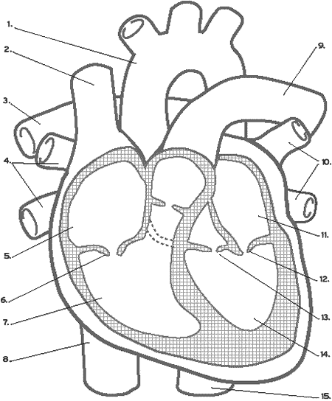

|  |
| --- |
| 1. Aorta |
| 1. Superior Vena Cava |
| 1. Right Pulmonary Artery |
| 1. Right Pulmonary Veins |
| 1. Right Atrium |
| 1. Tricuspid valve |
| 1. Right ventricle |
| 1. Inferior vena cava |
| 1. Left Atrium |
| 1. Left pulmonary veins |
| 1. Left atrium |
| 1. mitral valve |
| 1. Aortic Valve |
| 1. Left Atrium |
| 1. Aorta |

**Analysis Questions**

1. How can you tell which side of the heart is the ventral surface (the surface closer to your chest)?

The major blood vessels are on the top. The groove from the right side of the broad end of your heart extending diagonally to the bottom of the heart also tells you that it is the fro, of the heart, meaning the surface further away from the chest.

1. How many chambers are found in the mammalian heart? List these chambers.

-two atrias

-two ventricles

1. Which chambers are the pumping chambers of the heart?

-right and left ventricles on the bottom of the heart

1. Which chambers are the receiving chambers of the heart?

-right and left ventricles on the top of the heart

1. Describe the action of the tricuspid valve when the ventricle is full.

-the tricuspid valve opens to allow harder pump to allow blood flow into the lungs

1. Compare the structure of the tricuspid valve with that of the pulmonary valve.

-when the right ventricle contracts, the tricuspid valve closes, preventing blood to go to the right atrium, and the pulmonary valves opens, allowing blood to flow in the pulmonary artery towards the lungs.

1. How do the walls of the atria compare with the walls of the ventricles and why are they different?

Ventricles: thicker muscular walls - blood pumped out of the heart has a greater pressure to allow the blood to reach the lungs in order to obtain oxygen. The heart then needs these muscles to be thick in order to travel their desired space in a good pressure.

1. What is the purpose of heart valves?

They prevent the backward flow of blood

1. Name & compare the heart valves found between the upper & lower chambers of the right and left sides of the heart.

Right side: right atrium & right ventricle - separated by tricuspid valve

Left side: left atrium & left ventricle - they are separated by the mitral valve

1. Vessels that carry blood away from the heart are called superior vena cava, while Aorta carry blood toward the heart.
2. Which artery is the largest and why?

Aorta- because of its function and responsibility to pump oxygenated blood and transport it from the heart to parts of your body. The pump required to reach such goals then need to be strong enough to push this blood out.

1. What is the coronary artery? What would happen if this was blocked by a blood clot?

A coronary artery is an artery which supplies blood to the heart. If this is blocked, a heart attack will occur because of the heart's inability to receive oxygen by the blood clot.

1. Using words and Arrows: Trace blood flow through the major blood vessels and heart, starting with deoxygenated blood returned from the body.

