Food Resources: Vegan-based diets
Carla Frias

Planning

Research Question
Do vegan alternative food products offer the same amount of proteins as a non-vegan animal based food products?

Background Research
Proteins are biomolecules made of long chains of amino acids which provide regulation of the human body by producing body chemicals, such as hormones and enzymes, promote cells tu grow and repair, and facilitating the build of muscle and cartilage skin. ("The Benefits of Protein”) Thereafter, proteins are essential for the body to function properly and healthy and are mainly found on animal products, such as meat, eggs and dairy.

Nevertheless, vegetarianism is an option which has been recently promoted and widely spread through out society by their focus on becoming more socially or environmental responsible or by their desire to assist animal rights.(Crowford) Vegetarianism consists on obtaining their essential nutrients with the depletion of eggs, meats and dairies in their daily diets. Through such, they seek to change their eating habits in a way where it is healthy and sustainable over a long period of time. Thereafter, replacing vegan products are all in dependance to their products which offer the necessary proteins, such as beans nuts, seeds and grains.Their composition and effects are the same, yet their way they are consumed into the human body vary from product to product. (Frazier)
 | Named Variable | Unit | Manipulation
Independent Variable | Type of food | N/A | The lab will revolve around comparing the protein levels of products which are non vegan and vegan
Dependent Variable | Protein level | % (Daily Value) | Given in the nutritional value of the products bag
 |  | Grams per bag
Control Variable | Amount of product per bag | # | This will be controlled by dividing the total amount of product in their respective bag by the amount of protein (both grams and %) for each trial
 | Relationship between products | N/A | This being that the products being compared have to have some sort of relationship (soy milk/regular milk)
 | Location being sold | N/A | All data will be collected in Wong to maintain nutritional value precisness

Variables

Materials
- Wong
- 1 pen
- 1 paper

Products in Wong
- 5 different types of milk
  - Almond Milk
  - Soil Milk
  - Whole Milk
  - 1% Milk
- 5 different types of Meat
  - Soy Meat
  - Soy Chicken
  - Beef
  - Chicken
- 5 different types of Butter
  - Almond Butter
  - Cashew Butter
  - Regular Butter #1 (Dorina)
  - Regular Butter #2 (Sol de Oro)
- 5 different types of beans
  - Balck Beans
  - Cannellini Beans
  - Chickpeas
  - Kidney Beans
- 5 different type of nuts
  - Peanuts
  - Almonds
  - Cashews
  - Pecans

***If a product is not found at the designated supermarket, then it may be replaced as long as it follows their respective product type indicated in the data table (if a vegan product is missing, it may be replaced by another vegan product only)

Procedure
- The Supermarket Wong was approached
- The different products stated on the materials list were collected
- The server per container and protein value and percentage where collected for each product

Data Collection & Processing

Qualitative data
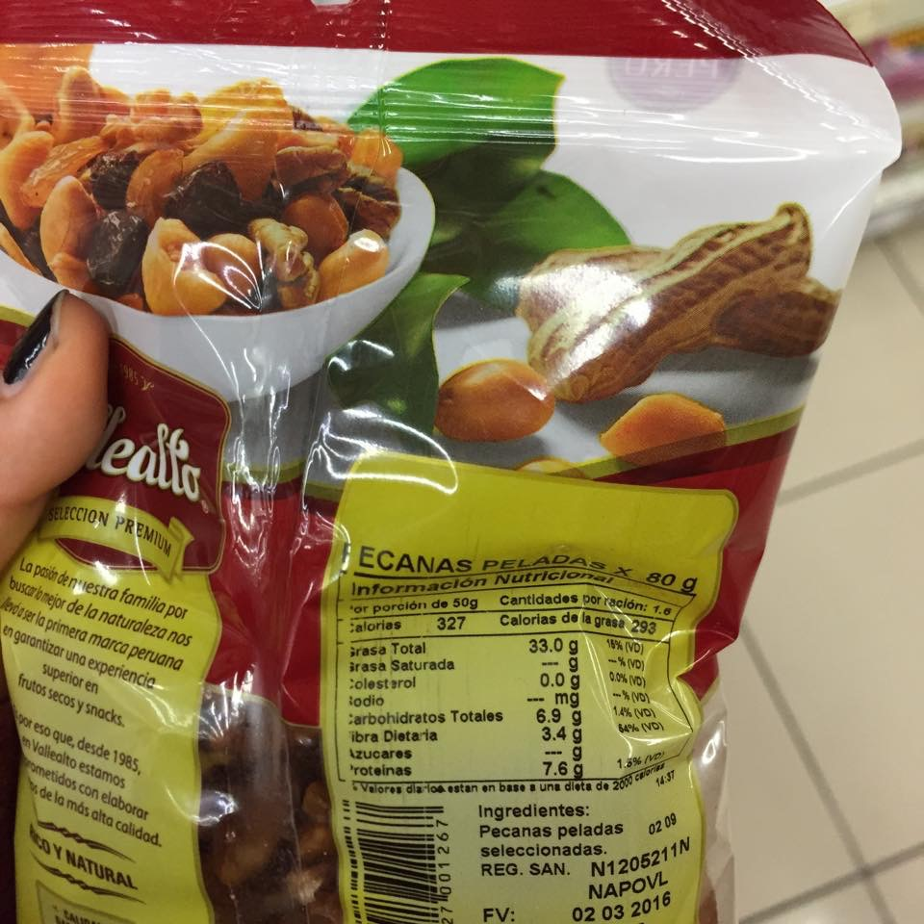
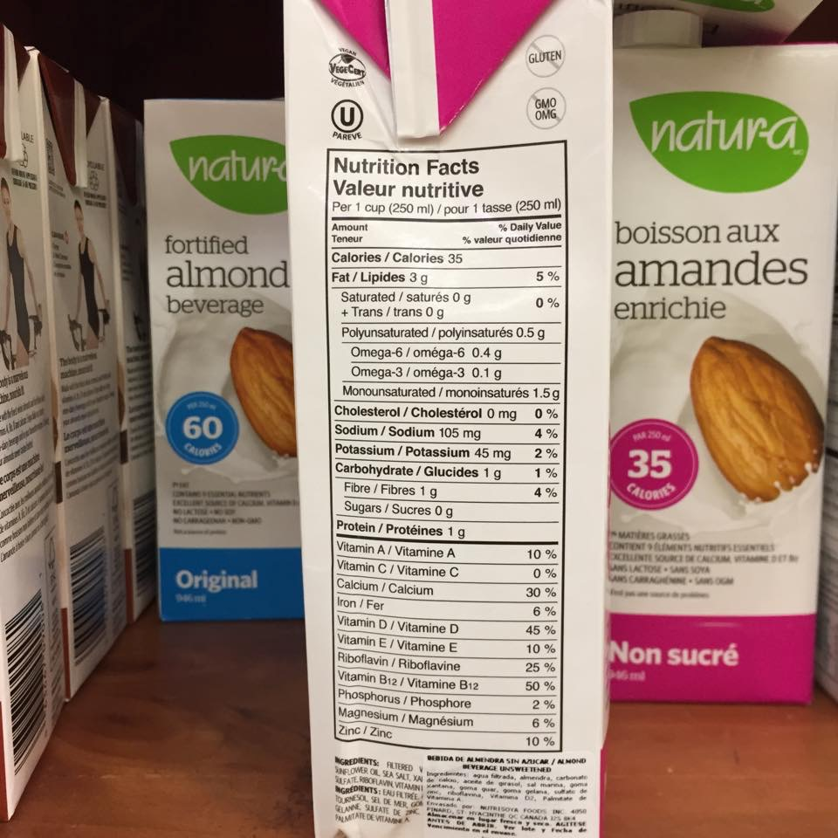
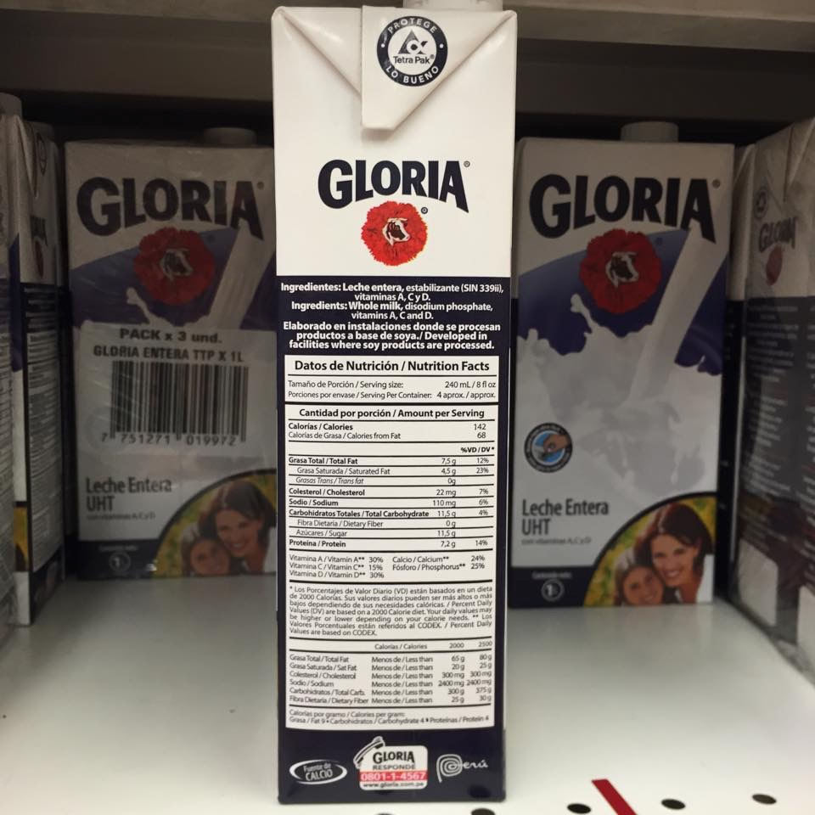

Quantitative Data
Table #1 (Raw Data Table): Vegan vs Non Vegan Food Protein Value
Product Category | Product type | Product | Quantity (g) | Protein (g)
Milk | Vegan | Almond Milk | 250 | 1
 |  | Soy Milk | 200 | 4
 | Non Vegan | Whole Milk | 240 | 7.2
 |  | 1% Milk | 200 | 6
Animal Products | Vegan | Soy Meat | 85 | 13
 |  | Soy chicken | 85 | 20
 | Non Vegan | Beef | 85 | 25
 |  | Chicken | 90 | 22
Butter | Vegan | Almond Butter | 28 | 7
 |  | Cashew Butter | 28 | 6
 | Non Vegan | Regular Butter #1 | 14 | 0
 |  | Regular Butter #2 | 100 | 0
Beans | Applicable to both | Black Beans | 85 | 16.5
 |  | Cannellini Beans | 120 | 6
 |  | Chickpeas | 164 | 15
 |  | Kidney Beans | 184 | 47
Nuts | Applicable to both | Peanuts | 146 | 38
 |  | Almonds | 28 | 6
 |  | Cashews | 129 | 22
 |  | Pecans | 28 | 4

Table #2 (Proccesed): Average and Percent Difference of the Protein Value Per 1 gram of Vegan vs Non-Vegan Products
Product Category | Product type | Product | Quantity (g) | Protein (g) | Protein per gram (g) | Average Vegan/Non Vegan Protein Value (protein/1 gram) | Percent difference (%)
Milk | Vegan | Almond Milk | 250 | 1 | 0.004 | 0.012 | 85.7
 |  | Soy Milk | 200 | 4 | 0.02
 | Non Vegan | Whole Milk | 240 | 7.2 | 0.03 | 0.03
 |  | 1% Milk | 200 | 6 | 0.03
Animal Products | Vegan | Soy Meat | 85 | 13 | 0.15 | 0.19 | = 34.8 \# "0" \* MERGEFORMAT34.8
 |  | Soy chicken | 85 | 20 | 0.24
 | Non Vegan | Beef | 85 | 25 | 0.29 | 0.27
 |  | Chicken | 90 | 22 | 0.24
Butter | Vegan | Almond Butter | 28 | 7 | 0.25 | 0.23 | 200
 |  | Cashew Butter | 28 | 6 | 0.21
 | Non Vegan | Regular Butter #1 | 14 | 0 | 0 | 0
 |  | Regular Butter #2 | 100 | 0 | 0
Beans | Applicable to both | Black Beans | 85 | 16.5 | 0.19 | 0.15
 |  | Cannellini Beans | 120 | 6 | 0.05
 |  | Chickpeas | 164 | 15 | 0.09
 |  | Kidney Beans | 184 | 47 | 0.26
Nuts | Applicable to both | Peanuts | 146 | 38 | 0.26 | 0.2
 |  | Almonds | 28 | 6 | 0.21
 |  | Cashews | 129 | 22 | 0.17
 |  | Pecans | 28 | 4 | 0.14

Sample Calculations
1. Protein value per gram
Protein (g)
Quantity (g)

Example —> 1/250 = 0.004

2. Average Vegan/Non Vegan Protein Value
(Protein/gram of Vegan/NonVegan Product#1 + Protein/gram of NonVegan/Vegan Product#2)
2
Example —> (0.004+0.02)/2 = 0.012

3. Percent difference (%)
(v1-v2) Where v1=Avg. Vegan Protein Value
(v1+v2)/2 v2= Avg. Non-Vegan Protein Value

Example —> ( (.012-0.03) / [(.012+0.03)/2)] ) x 100 = 85.7

Graph description

This graph shows that, while some non vegan products, such as beef and chicken, may offer higher amounts of protein, other additional vegan products, such as beans, butter and nuts, offer higher amounts of protein than non vegan products. The food sold at supermarkets then suggests by the graph that proteins can be found on different products for customers who wish to maintain high levels pf protein without eating animal processed foods.

Discussion

The availability of products in Peruvian super markets are endless, approaching their different customers in all ways possible by brooding the options offered to the public. Through such, Wong, as our targeted supermarket, did not only show the possibilities of product choices to their niche market, but also protein alternatives to those seeking to stop consuming animal processed products. Thereafter, such people who fall under the category of vegans diets, must maintain high protein product substitutes in order to maintain a healthy life style.

By taking a look at graph #1, we notice that the vegan animal products offered by Wong, meaning beef and chicken, had a higher protein value per gram than non vegan products. The percentage difference, by taking a look at table #2, between the the vegan and non vegan products where for almost 86%, meaning that soy milk and soy chicken, as products which where collected, are not efficient substitutes. Nevertheless, by taking a look at graph #1, the butter, a product which is widely used as a condiment for other processed foods (Stradley), was higher than non vegan butter, proving that, while non-vegan products under the category of animal products may offer higher protein values than vegan animal products, butter is a product which can be replaced as an alternative to obtain protein values which where not consumed by the depletion of beef and chicken. Additionally, by taking a look at table #2, beans and nuts are products which contain high protein values, reaching 0.15 and 0.2 proteins per 1 gram for their products as an average. This then means that such products which fall under the beans and nuts category offer, for some products, higher or almost as high protein values as non vegan meat animal products and milk products which reach 0.03 and 0.27 proteins per 1 gram of product as an average.

Evaluation

Weakness/Limitations | Impact on Results | Improvement
Number of products | The low amount of products for the milk, butter and animal products product category used limited the reliability and the preciseness of our conclusions. | Use more products under each category for every vegan and non vegan products. That way we can base our average protein per 1 gram on a wider amount of products
Place of data collected | The products we collected where all from one supermarket. This then meant that the amount of products that could have been analyzed where limited to those offered by the supermarket Wong. | Expand the investigation to other additional sources/supermarkets which amy allow comparison on protein values between products to increase the amount of data collected and thus reliability on conclusions and analysis.
Other nutritional values where not collected | When analyzing the healthiness of the product, we must also consider other nutritional component which may add on or decrease the benefits of a product. This is because fats influence the healthiness of products to a great extent. While proteins may be required to allow cells to functions, fats are vitamins that are absorbed by your body. | Add additional steps on the procedure which may not seem relevant to the lab but may offer extra information which can be added on on the appendix. In this case, other nutritional values such as the saturated, trans, poly unsaturated fats could have been recorded.
Adding more food categories | Because we are judging our conclusion on only animal, butter beans and nuts, other additional vegan and non vegan sources are being discarded, diminishing the amount of high protein product availability for vegans. | Increase the amount of data being collected by adding other food categories which may be easy to access on supermarkets here in Peru.
Product availability in Peru | When trying to collect some data, information had to be confirmed in the Internet by other American products because of the limited amount of products which are offered in Peru. The lab is then difficult to complete. | Use secondary sources as a way to verify data as well as obtain greater amount of data by online supermarket nutritional values offered (Whole Foods, Greens, etc)

Conclusion

Conclusion

While investigating if alternative food products offered to vegans had the same amount of proteins as animal based food products, a series of products where evaluated and compared in order to acquire such knowledge.

Proteins are biomolecules made of fat chains of amino acids, organic compounds which structure the cells in our body. Their essential function in life allows the storage of nutrients in our body to be used on basic needs, such as the repair of malfunctioned tissues, the removal of waste products in our body through metabolic processes, along others. ("What are amino acids?"). These proteins are not only key to a healthy biological life, but also provide regulation to the human body by producing hormones and enzymes, essential for the cells to grow, the hemoglobins which carry oxygen in our blood and the cells ("The Nutrition Source - Protein") which facilitated our muscles to build.

Thereafter, proteins are considered ‘macronutrients’ ("The Importance of Portein"), meaning they are needed in large quantities in order to maintain stability in your body. There disability to be stored in the body ("Proteins"). requires humans to constantly consume different products which make up for the proteins needed in your body, in respective of you daily activities and body mass. ("The Nutrition Source - Protein"). As a result, humans tend to find such proteins on animal based products, such as meat and chicken, which offer the amino acids that we need, yet issues on maintaining the levels of proteins needed come to those which deplete the consumption of non animal produced products.

The results collected demonstrated that, while some animal products offered greater amount of proteins than alternative non based animal products, such as beef and chicken compared to soy meat and soy chicken or milk compared to soy or almond milk, there where other food alternatives which could make up for those proteins not received by restricting the consumption of non vegan products, in this case, beans and nuts. While, on average, animal products gave 0.27 proteins per gram consumed, nuts gave 0.20 proteins per gram consumed. Additionally, while regular milk gave, on average, 0.03 proteins per gram consumed, beans gave 0.15 proteins per grams consumed. This then demonstrated that, while food that did not contain nor milk, nor egg nor any other animal processed product, had greater or equal amounts of protein, it did have high value of proteins. The option of consuming vegan products may then not be as high on proteins and non vegan product, but did offer a value which could be added on as a daily diet if managed and properly divided on quantities.

Vegan diets then tend to seek on alternative food sources which offer high protein values in order to maintain a healthy life style while maintaining their moral values towards animal use for human consumption. However, both vegan and non vegan consumers may take in consideration the type and amount of fats that are offered by the picked food product. Fats, either saturated, polyunsaturated, monounsaturated or unsaturated, are what supply essential A, D, E and K vitamins to your body to allow energy production, cell building oxygen transport, blood clotting and active hormone substances. ("Nutritional Adjuncts to the Fat-Soluble"). Nevertheless, while fats may be good to the body, it can also offer some limitations. By consuming products which offer very high values of polyunsaturated fats, the decomposition of enzymes to break down food molecules begins to decrease. This can then lead to an increase in a persons cholesterol, meaning arteries which help the oxygen of your blood to flow are blocked and diminished. ("The truth about fats").

Furthermore, the RDA, Resource Description and Access, recommends an average of 0.8 grams of protein per kilogram that we weight per day. Such level can then be reached by introducing foods which, instead of containing animal based products, contain alternative food sources. ("Protein in the Vegan"). Regulating the amount of proteins that we consume can be achieved if we are aware of the options given to us in the foods we eat. We must must be aware of, not only the products, but the quantities we consume to achieve the needed proteins for a healthy body to be maintained. Through a regulated diet consisting of beans and nuts, we can attain the essential amino acids that would be consumed on an animal based diet. ("Best Vegan and Vegetrian").

Thereafter, while non vegan products may offer high amounts of proteins, their fats are not yet considered in the nature of the products, limiting the reliability of the conclusions we come to during our investigation. Nevertheless, while fats are not yet considered, a later study on the correlation between proteins and fats could be achieved to further extent the knowledge on maintaining a healthy life through the products we consume.

Works Cited
"The Benefits of Protein." WebMD. MedicineNet, n.d. Web. 6 Oct. 2015. <http://www.webmd.com/men/features/benefits-protein>.
"Best Vegan and Vegetrian Protein Source." Heatlh. N.p., n.d. Web. 11 Oct. 2015. <http://www.health.com/health/gallery/0,,20718479,00.html>.
Crowford, Elizabeth. "Vegan is going mainstream, trend data suggests." Food Navigator USA. News Media, n.d. Web. 6 Oct. 2015. <http://www.foodnavigator-usa.com/Markets/Vegan-is-going-mainstream-trend-data-suggests>.
Frazier, Matt. "Protein for Vegetarians — A Simple Guide to Getting What You Need - See more at: http://www.nomeatathlete.com/where-vegetarians-get-protein/#sthash.VbcqpA88.dpuf." No Meat Athlete. N.p., n.d. Web. 6 Oct. 2015. <http://www.nomeatathlete.com/where-vegetarians-get-protein/>.
"The Importance of Portein in Your Diet." Detour. N.p., n.d. Web. 11 Oct. 2015. <https://www.detourbar.com/protein-basics/the-importance-of-protein-in-your-diet>.
"Nutritional Adjuncts to the Fat-Soluble Vitamins A, D, and K." Articles Mercola. N.p., n.d. Web. 11 Oct. 2015. <http://articles.mercola.com/sites/articles/archive/2013/03/18/fat-soluble-vitamins.aspx>.
"The Nutrition Source - Protein." Harvard School Of Public Health. Harvard University, n.d. Web. 11 Oct. 2015. <http://www.hsph.harvard.edu/nutritionsource/what-should-you-eat/protein/>.
"Protein in the Vegan Diet." The Vegetarian Resource Group. N.p., n.d. Web. 11 Oct. 2015. <https://www.vrg.org/nutrition/protein.php>.
"Proteins." BBC. N.p., n.d. Web. 11 Oct. 2015. <http://("The Importance of Portein").>.
Stradley, Linda. "Condiments and Sauces Recipe Index." What Cooking America. N.p., n.d. Web. 11 Oct. 2015. <http://whatscookingamerica.net/Sauces_Condiments/SaucesCondimentsIndex.htm>.
"The truth about fats: the good, the bad, and the in-between." Harvard Health Publications. N.p., n.d. Web. 11 Oct. 2015. <http://www.health.harvard.edu/staying-healthy/the-truth-about-fats-bad-and-good>.
"What are amino acids?" Amino Acid Studies. N.p., n.d. Web. 11 Oct. 2015. <http://www.aminoacid-studies.com/amino-acids/what-are-amino-acids.html>.

