2.1 – Functions & Evolution of Human Resource Management

Human Resource Planning
- The management function of using & developing a person within a business to meets its org. objectives

Output:
- Increase productivity
- Improve quality (new ideas)
- Better customer service

Roles
- Workforce planning
- Recruitment, selection, induction
- Training & developing staff
- Reviewing pay
- Disciplinary procedure
- Welfare employees

Workforce planning
- Short-term: existing & upcoming ideas
- Long-term: looks at human resources needs in the future
Demands
- Historical data & trends – change in size of workforce
- Sales & income levels – higher income more employees
- Labor turnover rates –
- Flexibility & workload
- Demographic change – gov. data

Labor Turnover
- % of workforce leaving org. in given period of time

LT= (# of staff leaving) x 100
(Total # of staff)

- Low Labor Turnover = right recruitment
- High Labor Turnover = add cost of recruitment & training
        - Low productivity
- Staff Retention = Organization keeps employees
      - Org. offers personal/professional development training
      - Boost morale
Reasons: Quitting A Job
Accept high rate of LT (org)
- Relatively low wages
- Pay to unskilled workers
  - C -hallenge
  - L –ocation
  - M –oney
  - P –ride
  - J –ob
  - Lack job satisfaction
  - Better opportunities

Internal/External Factors Influencing Human Resources

1- Demographic Changes
- Statistical study of population

Caused by:
- Net birth rate (R=BR – DR)
- Net Migration rate (immigrants vs. emigrants)
- Retirement Age (if it raises increases people in labor force)
- Women
- Ageing population: avg. age of living increases

Effects of Ageing Population
- Increase dependent population
  - DP=below legal working age, out of work, retired
  - Supported by working population – TAX PAYERS
  - Less working/more retired pressure on tax payers

- Reduced Labor Mobility
  - Reduces flexibility & international competiveness of workforce
  - Can’t move

- Changes in consumption patters
  - Firms create opportunities for more mature groups
  - Objects/things they need

- Changes in employment patters
  - Keep retired people despite age
  - Labor supply shortages

2- Changes in labor Mobility
- Geographical Mobility: extent to which labor can move to different places
- Occupation Mobility: flexibility of changing jobs
- Mobile Workers: both high supply of labor

Limitations G. M
Limitations O.M.
-Acquired attributes (education, skills, etc.)
-Young people change careers/older is to risky
-Highly specialized in an area
-Discrimination
-Friends & family
-Moving expenses: remortgaging property, house $
-Unfamiliar area/cost of living/language/culture

3- New communication Tech.
- Business capital-intensive = not so many workers required
- Communication & info tech. (ICT)
  - Support current activities in workforce planning
  - Improve it

Examples
- Recruitment – app online
- Meetings – conference call
- Appraisals – Google Doc.
- Flexitime & teleworking – work at home
- Online Training process – cost-effective

Recruitment & Selection

Internal Recruitment: hiring people who already workers for that business promoting, relocating, redeploying

Advantages | Disadvantages
- Cost effective – quicker & cheaper  - Less down-time  - Less risk – of abilities & skills  - Motivational – promotional opportunities | - Fewer applicants  - Dead Wood – no new ideas  - Time consuming – leads to another unfilled vacant  - Internal politics- resentment/conflict on not receiving promotion

External Recruitment: hiring people from outside the business
- Newspaper advertising
- Specialist trade publication – target specific audience
- Internet advertising
- Commercial employment agencies – charge a fee but save time
- Job center – non-profit org. by gov. for low paid jobs
- Headhunting – new company offers a contract & pay deal
- University visits
- Employee referral – personal recommendation by current employee

Advantages | Disadvantages
- New Blood – new ideas  - Wider range experience  - More applicants | - Greater uncertainty  - Time-consuming  - Expensive

Recruitment Process
- Conduct Job Analysis
- Produce Job/Personal Description
- Advertise Job (TAPS: trustful, relevant, accurate, positive, short)
- Check apps & list of candidates
- Interview
- Perform Aptitude test (if applicable)
- Choose best one
- Sign Contract
- Carry induction

Application Process
- Application form
- Curriculum Vitae – education, employment, history, skills, qualification
- Cover Letter – why you?

Selection Process
- Shortlisting – company app. Form & CV. Versus Job Description

Interview Process
- Get more info on job
- Through: video-conference, telephone, face-to-face, group
- Be prepared, dress appropriately, practice, don’t be late/critical/liar

Behavioral-based questions: assess a candidates behavioral pattern & initiative
Situational-based question: assess judgmental ability, hypothetical scenarios

Testing Process
- Psychometric test: personality
- Aptitude Test: ability & skill on pressure
- Intelligence test: mental ability
- Trade Test: candidates skill & specific position

References
- Statements about an applicant
- Done by previous employer

Contract
- Entitled by the law
- Terms & Conditions
Induction
- Helps settle in roles
Training
Workers acquire employment-related skills and knowledge

Objectives of training
- Enhance efficiency and effectiveness
- Improve quality of work
- Facilitate career
- Develop multi-skills
- Helps adapt to changes: technology

Advantages | Disadvantages
- Better skilled  - Greater efficiency = better productivity  - Higher morale  - Good reputation for training attract good quality workers  - More competent to role better quality of output  - Better adjustment to role | - Financial cost  - Time consuming

Types of Training
- On the Job
- Carried out while at workplace
- Learning by doing
- Induction Training: introducing new employees to the organization, integrate, meet key personnel, tour, learn job role,
- Mentoring: partnership between 2

- Off the Job
- External specialist are used (expensive)
- Key personnel come and pass knowledge to their team

- Cognitive Training
- Training & developing mental skills to improve work performance (to certain people)
- Improve memory, attention, listening skills, logic & reasoning, visual & auditory processing, self control, time managing
- Limitation: might be expensive, not resourceful

- Behavioral Training
- Identifying work-related problems to improve performance by behavioral change in the workforce (everyone)
- Team building, ethical business practice, emotional intelligence, motivation, conflict resolution, stress/anger management, leadership

Appraisal
Formal assessment of employees performance in fulfilling tasks & responsibilities

-annually/quarterly
- Performance management: planning, reviewing & mentoring employee’s to enhance performance at work

Reasons
- Assess & record employees performance with targets
- Staff reflects on performance
- Opportunity to praise staff for good work
- Identify barriers
- Identify appropriate training/development needs
- Set new target, goals improvements
- Aid professional development/management for promotion

Limitations
- Time consuming
- May get offended by feedback/anxiety and stress
Types
1- Formative:
- Evidence used to inform employees on what to do to improve work practices
- Monitor performance, identify strength/weakness

2- Summative
- Written description of employees performance at work
- Personal achievement during the year, test knowledge/competence

3- 360-degree Feedback
- Collecting evidence from peers, subordinates, line managers with direct contact to employee
- Provide useful and practical feedback to improve
- Very bias

4- Self-Appraisal
- Self-reflection based on predetermined criteria
- Rate themselves, set targets for improvements

Steps
- Staff records & reports
- Appraisal meeting
- Written report of the appraisal
- Appraiser & appraise sign the written report
- Countersignature from senior manager

Low rating Actions
- Warning letters
- Counseling, advice
- Dialogue concerns and consequence
- Closely monitor performance
- Dismiss the employee

Dismissals & Redundancies

Dismissals – termination of workers employment due to unsatisfactory performances:

- Fair Dismissal: evidence gathered (record of appraisal meetings, email, feedback) + dismissal communicated to the rest of the team
- Unfair dismissal: dismissed without valid/legal reasons:
- Discrimination
- Constructive dismissal – forced to quit

Reasons:
- Incompetence: lack of ability
- Misconduct: unacceptable behavior (late, rude, harass)
- Gross misconduct: major misdemeanors (thefts, fraud, drunk)
- Legal requirement: not necessary skills (dishonest qualifications, abilities, experience)

Steps
- Verbal Warning
- Official Written warning –meeting to improve in given timeframe
- Official Dismissal

Redundancies – business can’t afford to employ the worker/job ceases to exist

- Voluntary Redundancies: employer asks for volunteers to leave, offered redundancy package
- Compulsory redundancies: employers chooses which worker to make redundant
  - LIFO method: last in, first out
  - Retention by merit method: least product workers are made redundant
- Redeploy: transferring employees to other departments
- Decrease wage

Changing Employment Patterns & Practices

Employment Sector
- Primary, secondary, tertiary & quaternary

Ageing population
- Low Birth Rates + High ageing = avg. workforce rise
- Shortage in labor supply affects workforce planning, recruitment & planning

Flexile work structures
- Business uses less core staff
  - Improve flexibility (work from home, restructuring, flextime, less recruitment practices, retaining core staff)
  - Low labor costs

Teleworking
- Working away from office through electronic forms
- Call centers – workers deal with customers complaints on the telephone
- Homeworking – work from their own home

Portfolio Working
- A person employed in a number of different of jobs (gardeners, plumbers)
- Experiences fulfill career
- Lacks job security

Part-Time employment
- Lower remuneration (pay & benefits)
- Wages are low, adjustable working hours
- Turnover is higher (less values) inducting & training is expensive

Flextime
- Shift work
- Flextime: employees work for a core period
- Reduce paying staff for work overtime, extended normal working hours, provide equal opportunities, greater freedom

Migration of workers
- A person engaged in remunerated activity in sate that he/she is not national
- Contribute to economic growth – higher production, consumption, payment of taxes

Reasons
- Pay & Remuneration
- Employment Opportunities
- Seasonal Factors : farmers
- Domestic instability: political, security limits business opportunities
- Higher standard of living

Outsourcing, offshoring & re-shoring

- Globalization: intensified competition in industries
  - Cost advantages
    - Firm can reduce prices to gain market share create greater profit margin
    - Prices are unchanged but operation on larger scale greater profit margins

How?
Outsourcing:
  - When someone takes care of a part of your business (you still get profit)
  - Transferring internal business activities to an external firm (where they have specific skill) to reduce cost of production
  - Subcontractors : (outsourced firms) carry outsources work for less money than their clients
  - Apple, security

Advantages | Disadvantages
- Specialist are hired  - Subcontractors will bid for the outsourced work  - Reduces labor costs  - Allows concentration on core activities  - Improves workforce flexibility | - Subcontractors high under-aged, illegal, unqualified workers  - Quality manag. Is difficult  - Conflicting views of quality  - Subcontractors needs to be monitord  - Can cause redundancies in org.  - Exploitation of labor in LEDC

Offshoring:
- An extension of outsourcing
- Relocating business activities and processes abroad
- Offshore outsourcing: exporting work from MEDC to areas of the world where there is:
  - Political stability
  - Lowe labor cost
  - Les imported taxes issued
  - Firms access latest tech.
  - (India: call centers; China: shoes)

Limitations
- Quality managing issues
- Adverse fluctuations in exchange rate: Cost saving are wiped out
- Host country has inflation rises in min. wages

Re-shoring:
- Transfer of business operation back to their countries of origin
- Why?: Decline of cost-effectiveness

Reasons:
- Product recall
- Mass-media coverage of outsourced business being unethical
- Limited monitoring of quality
- Transportation costs rise – more cost-effective
- Increased demand for customization of product – customers demand
- Bring back jobs
- Balance gov. budgets

Human Resources planning & CUEGIES
- Effective managers consider cultural impact
  - Appraising may be disrespectful to senior managers

- Globalization & Innovation– information communication technologies (ICT)
  - how tech. helps workforce planning
  - Improve capabilities, efficiency and functions of organization

- Managers not making the most of human resources then:
  - Recruitment - Higher cost
  - Resources – achieving less org. objectives, more personal problems
  - Reservations – lower morale and higher uncertainty of staff
  - Return – low labor productivity, profits
  - Reputation – poorer corporate image

2.2 – Organizational Structure

Business functioning efficiently
- Accountability: who is responsible for each job
- Responsibility: who is in charge of whom & what role/capacity

Delegation & Span of Control

Delegation: passing the control and authority to others
- Entrusting & empowering staff to complete task
- Manager not having to complete all tasks
- Motivate employees, feel trusted

SMARTER Delegation
Specific: task is defined
Measurable: results must be quantifiable to measure success
Agreed: managers & subordinates agree delegated task
Realistic: reasonable, achievable
Ethical:
Recorded

Span Control: # of people directly accountable to a manager
- Higher hierarchy higher span control
- Advantage: fewer layers needed, better communication & cost control

- *CEO: responsible for Board of Directors & in charge of all workers in the org.

Factors: degree of control granted to manager
- Manager – the more skilled & experienced
- Organizational culture – monitor & control subordinate, show span of support
- Subordinates – highly skilled staff (work in small teams) with high SC
- Task – complex, urgent & important higher SC + more communication
Mass-produced product: less supervision less SC + less workers

Levels of Hierarchy

- Hierarchy: the organizational structure based on a ranking system
  - CEO, Chairperson, Board of Directors
- Line Manager: person directly above an employee on the next hierarchical level
  - Responsible for ad to day management of subordinates
- Subordinates: Next level down

Chain of command
- Formal line of authority where orders are passed down in org.
- Few levels of hierarchy short chains
Delayering
- Process of removing one or more levels in the hierarchy
- Reduces # of layers + widens span of control

Advantages | Disadvantage
- Improve coordination & productivity  - Show lines of communication  - Establish departments/teams  - Reduce costs  - Encourages delegation & empowerment | - Departmentalization: Workers are isolated from teams  - Not flexible  - Creates anxiety & insecurity  - Overloads staff – less quality  - Long decision making

Bureaucracy
- Execution of tasks that are governed by official administrative & formal rules of an org.
- Division of labor applied to the administrative tasks within an org.

Excessive administration, paperwork, long official lines of command, managers with 2+ roles & formalities

Principles
- Continuity – follows official rules & regulations
- Rules & regulation – lines of authority, responsibility, accountability
- Hierarchical structures –
- Accountability – written evidence of workers performance

De/Centralization Structure
- Extend of concentrated authority, trust & corporate culture

Advantages | Disadvantages
Rapid decision making | Pressure/stress to senior staff
Better control | Inflexibility
Better sense of direction- greater knowledge | Possible delays on decision-making
Efficiency | Demotivating
Good communication | No team work
Centralized Structure:
- Small # of people in decision making
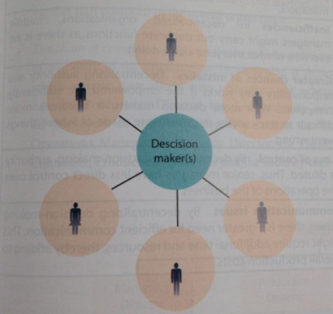

Decentralized Structure:
- Decision-making authority & responsibility is shared with others

Factors: Choosing Structure
- Size of org. (larger need of decentralization)
- Scale of importance of decision (high-cost?)
- Level of risk
- Corporate culture (if needed creativity)
- Manag. Attitude & competencies
- ICT (information communication tech.)

Organizational Charts
- Diagrammatic representation of firm’s formal structure
- Shows:
  - Chain of command
  - Functional departments
  - Span of control
  - Channels of communication
  - Levels of hierarchy

Flat & Tall Organizational Charts
Flat Organizational Charts:
- Few levels
- Each manager: wide span of control

- Delegation is important
- Cheaper to operate
- Better communication

Tall Organizational Chart:
- Many hierarchy levels
- Narrow span of control

- Quick, effective communication
in smaller teams
- Specialization & division of labor
More productivity & efficiency
- More opportunities

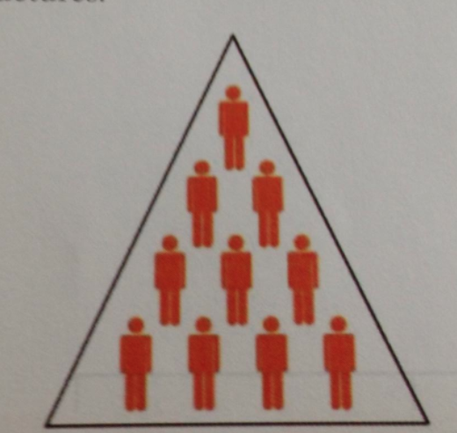
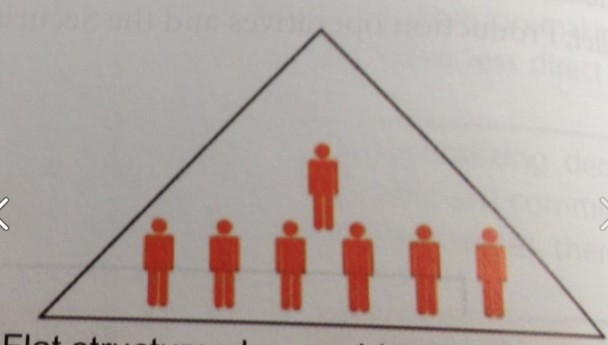

Hierarchical Organizational Chart
- Subordinates reporting to their line manager
- Position: indicates rank, status, level of authority
- Tall Hierarchical = bureaucratic (long)

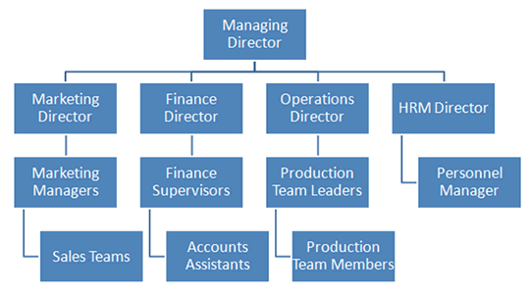

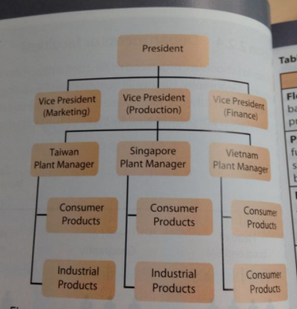
Organizational Structure
- Organization by function: different operation roles
- Organization by roles: multinational companies organized by geographical region
- Organization by Product

Project-based organization
- Increase flexibility to adjust to market changes productivity
- Project manager with a team of workers
  - Isolation of team
- Used for temporary period for specific projects efficient, control

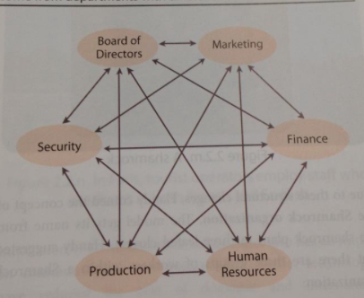
Matrix structure
- Flexible org. of employees from different departments within org.
- Temporarily working together
- Each member: accountable to two managers –official department & project manager

Handy’s Shamrock Organization

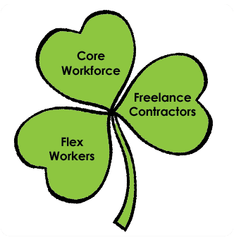
3 groups of workers
- Core Staff: full-time professional workers, daily operations

- Peripheral Workers: part-time, temporary workers, employed when needed, paid at rates reduce labor costs

- Outsourced workers: individuals not employed by org, paid to complete particular & specialized tasks

Impact of culture & ICT on communication in organization

Culture
- Different languages
- Cultural ignorance – may offend
- Recruit bilingual/multilingual employees
- Internet helped (translation)
ICT
- Email – data transmission, high tech. cost
- Mobil Device
- Video Conferencing

Organizational Structure & CUEGIS
- Causes motivation, effort, reduce communication problems, high coordination
- Managers have to be aware of cultural differences & approaches
- Larger firms requires more organization
- Good Management attitude

2.3 Leadership & Management

Key functions of managers
- The roles & responsibilities of managers

Functions: Henry Fayol
- Planning – setting the course of action
- Commanding – give instructions/orders
- Controlling – performance, health, safety of their teams
- Coordinating – teams achieve goals of org
- Organizing

Functions: Charles Handy
- Managers as general practitioners
  - Organizing health problems of firm: level of staff turnover, productivity, costumers satisfaction

- Managers as confronters of dilemmas
  - Required to let go of some authority when delegating work to teams
  - Also retain responsibility for assigned tasks
  - Management of stakeholders

- Managers as balancers of cultural mixes
  - Balance cultural mix in org
  - Get the best of each individual

Functions: Peter F Ducker
-Managers: not too involved in daily activities of employees

- Setting organizational objectives
- Organizing tasks & people
- Communicating with & motivating people
- Measuring performances
- Developing people: bringing out the best in people

Management vs. leadership

- Leader: someone who influences & inspires others to get things done
- Leadership: process of influencing & inspiring others to achieve organizational goals

- Managers: focus on achieving specific goals within a definite time frame
- Management: planning, organizing & coordinating human and capital resources to achieve organizational goals

 | Management | Leadership
Time & Devotion | Defined time frame | 24-hours each day
Roles & Responsibilities | Innovative thinkers  -How and when? | Broader range  -What and why?
Influence on others | Instructions and orders are listed | Inspire and motivate their followers through actions
Concentrate on | Task | People
Risk-taking | Follow predetermined rules & policies set by org. | Take risks by challenging the status quo
Vision | Abide by procedures and culture of org. | ‘a dealer in hope’- create a culture of hope

Leadership Styles
- Decision makers behave/reveal their behavior

Autocratic
- One who makes all the decisions
- Prefers not to delegate any responsibility
- Tells subordinates what to do – opinion/suggestions are ignored
- Can cause resentment of employees, labor turnover, absenteeism

- Used: when needed fast decision-making, unskilled labor

Paternalistic
- Treat their employees as if they were family members
- Guide them through consultation process

- Negative paternalistic style: leader perceives the workers as less than capable
- Positive Paternalistic style: leader perceives workers as highly capably

Democratic
- Involves employees in the decision-making process
- Consult staff & consider views before final decision
- It delays decision making (not for large workforce)

Laisseze-fair
- Minimal direct input in the work of employees
- Allow subordinates to make their own decisions & complete tasks in their own ways
- Motivation: staff feels trusted
- Coordination & decision-making is time consuming

Situational leadership
- Not based on any single dominant approach
- Using right leadership for right situation
- Adopting to change and style

Factors affecting S.L. Styles:
- Culture
- Leader – trust on employees, experience
- Organizational Structure – hierarchical structures tall/flat? Span of control?
- Task – difficultness, urgent, important?
- Subordinates – level of skills, motivation, unity

Leadership, management & CUEGIS

- Cultural- tradition & expectation that leaders make is different in countries
- Ethical – leaders personal values and moral judgment
- Delegation & empowerment – leaders fulfill strategic responsabilities
- Shift from: Autocratic democratic style
- Leadership affects level of morale, commitment & competence

2.4 Motivation

Motivation
- The desire, effort & passion to achieve something

Motivation theory: how managers seek to motivate workforce to maximize job, satisfaction, staff morale & labor productivity

Benefits:
-Higher morale/job satisfaction
-Better industrial relations (less conflict in workplace)
-Low nonattendance
-Low staff turnover (reduced cost of hiring)
-Higher profitability

Motivation Theories:

-Federick Taylor (1911)

Principles of scientific management:
- Employees want higher wages
- Productivity could be improved by setting output/targets related to pay

Promoted:
- division of labor
- Assign job/task to people based on abilities rather than potential
- Specializing the production process
- Improve efficiency & output

- Differentiated piecework
- Workers wage: standard level of output
- Receiver high rate if exceed of that level
- Rewards more
Waged-Staff: no input into how things are doing/paid different
Limitation
- Ignored non-physical contributions: higher level of education
- Workers have no voice in decision-making
- Has repetitive/monotonous tasks job dissatisfaction

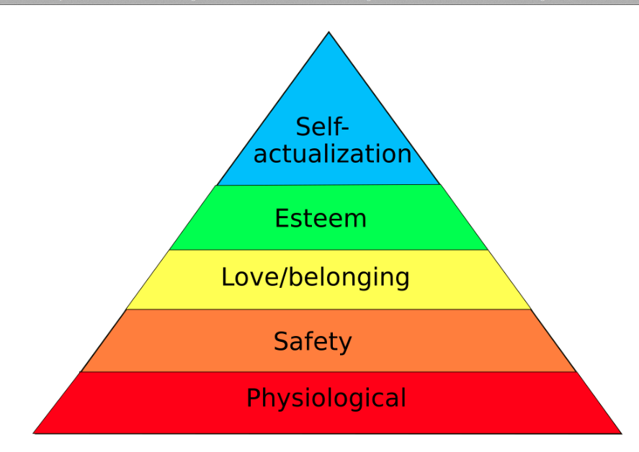
-Abraham Maslow (1943)
- Based on the psychological/hierarchy needs of workers
- Meeting lower level needs before higher level needs

Lower Level Needs
- Psychological needs: water, food, air, sleep, etc.
- Security needs: job security, sick pay, maternity leave, pensions (retirement income)
- Social needs: communications, social gatherings, etc.
- Esteem Needs: Internal: self respect - External: recognition, self respect
- Self-actualization: be the best that you can be – promotions

Limitations
- Measure level of needs
- Model pyramid not accurate/appropriate for everyone
- What motivates people once they reach self-actualization?

-Frederick Herzberg (1959)
- Sociological and psychological aspects of work
- 2 factors affecting motivation:

Hygiene Factors: physical
- Meet basic needs to ensure no demotivation
- Become an expectation/granted
- People have different needs
- Limited to low-skilled/paid jobs

- Organizational rules, regulations, policies, working conditions, pay regulations
higher wages: doesn’t motivate, its already expected by contribution to work

Motivators: psychological
- Psychological growth satisfaction
- Achievement, recognition, responsibility & advancement of work

- Democratic leadership style: train tasks to staff
- Job Enlargement: more tasks given challenging
- Job Enrichment: complex jobs exploit potential
- Job Empowerment: delegating decision-making power to workers

- Motivation vs. movement
  - Motivation: people do something because the want to
  - Movement: people do something because they need to

-Adam’s Equity theory (1963)
- Workers naturally compare their efforts/rewards to others
- Each worker has:
  - Remuneration- salary + fringe benefits reflects effort
  - Input-Outcome Ratio is fair in relation to others
(Contributions made by employee - non/financial rewards)

Impact:
- Equity norm: workers expect fair remuneration
- Social comparison: determine what is fair by comparing to workers
- Cognitive distortion: workers feel like inputs are greater than outcomes
- Inequities: greater input receive less effort cause high absenteeism

-Daniel Pink (2009)
- Monetary rewards motivate workers
- Bonuses & commissions block essential skills of creativity
- ‘Baseline Rewards’ (salaries/perks): satisfy basic human needs
  - Internally fair: what they are being paid for
  - Externally fair: paid in comparison to others

Factors that motivate
- Autonomy – self-sufficient, new tasks, time, techniques, teams
- Mastery – self-improvement, learn/create, Goldilocks Tasks- not too simple or hard
- Purpose – self-esteem, how they contribute to prupose of org.

Types
- Type X (extrinsic): motivated by money, etc.
- Type I (intrinsic): engage in own desires activity

Financial Rewards

1. Salary
- Financial rewards as fixed annual rate paid monthly
- Where output & productivity can’t be measured

Limitations
- Can’t distinguish output no rewards
- All paid the same amount little incentive to work harder
Solution: performance manag. & Performance appraisal (2.1)

2.Wages (time/price)
- Rewards for labor services hourly or output measure
- Depends on output and not on effort

-National minimum wage: gov. sets a stated rate of payment
-Overtime rate: wage earners paid for extra hours
-Piece rate: pays workers for each item produced/sold
- Incentive to maximize incomes

3. Commission
- Pays workers based on a portion (%) of sales/output
- Org: financial rewards = incentive to work more
- Have a basic salary

Limitations
- Speed production
- Aggressive selling
- Added pressure to sell more
- Repetitive tasks
- Lacks security needs
- Hire quality controllers

3. Profit-related pay
- Pays depending on profits in the firm
- Annual bonus
- Result by team effort
- Boost labor efficiency
- No individual recognition

4. Performance Related Pay (PRP)
- Rewards employees meeting certain goals
- Goals: sales targets, competence in job, contract completion

Payment Methods
- Pay rise – meet/exceed targets
- Performance bonus - reached output/quality targets
- Gratuity – meet employment contract

5. Employee share ownership schemes
- Rewards workers, managers, directors by giving them discounted prices, selling the shares
- Impact greater interest on wellbeing of org.

6. Fringe Payments (perks)
- Financial benefits in addition to wage/salary
- Encourage employee loyalty/safety needs,
- Feel more valued
- Potential high cost
- Health insurance, housing allowance, retirement fund, staff discounts, subsidizes meals

Non- Financial Rewards

1. Job Enrichment
- More challenging jobs & responsibilities

Pros | Cons
Range of tasks better sense of achievement | Added expenses – train
Autonomy/psychological growth | Workload increase
Greater authority | Risk: not too challenging to low-skilled workers

2- Job Rotation
- Perform different task at same level of complexity in a systematic way
- Provide more variety
- Avoid overspecialization: boredom
- Cover for absent colleagues

3- Job Enlargement
- Broadening the # of tasks with the same job itself
- Reduce monotony (repetitive) of tasks boredom & demotivation
- Can cause workload for same amount of pay

4- Empowerment
- Developing potential of workers
- Granting authority, decision-making
- Boost motivation/pride

Achieved through methods:
- Delegation – pass authority to subordinate with competence (ability) & desire
- Worker participation – workers help on decision-making (suggestions)
- Continuous professional development – ongoing training to progress in their career

5- Purpose
- Making a difference to the world (altruistic)
- Build ongoing relationship with beneficiaries
6- Teamwork
- Meet social needs/no boredom
- Build sense of belonging low labor turnover, greater productivity

Types
- Departmental teams – functional teams
- Cellular manufacturing – complete part of production process
- Quality circle – team members meeting to discuss solutions to problems

Motivation & CUEGIS
- What motivates one person doesn’t motivate the other
- Cultural norms – people better suited to a system fo scientific manag.
- Intrinsic & extrinsic depend on situation/person

2.5: Organizational (Corporate Culture)

Corporate Culture: the beliefs, values & attitudes of the manag. & employees

Elements of organizational culture
- Nature of the business: purpose and directions of the organization (mission, aims, objectives)

- Organizational Structure: tall/flatter structures (lots of small teams or non) & highly skilled innovative staff vs. demotivated staff

- Rewards: motivated workforce appropriately remunerated develop strong & united culture

- Management: de/centralized organizations: management has to solve all problems?

- Sanctions: few encourages slack of workers

Importance
- Cultural intelligence: ability of individual to blend into occupational, corporate & national cultures
  - Ability to adjust to unfamiliar situations
- Depends on degree of unity: no cultural gap

***cultural gap: the difference between the desired culture of a business & the culture that actually exits (in subgroups)
Advantages:
- Sense of belonging/security to staff
- Promoting cohesiveness
- Reduce mistakes/misunderstanding
- Minimizing problems

Types

1- Edgar H. Schein

Corporate Culture levels
- Artifacts: superficial/behavioral aspects
- Espoused values: desired/expected culture
- Shared basic assumptions: culture not seen by integration in organization

2- Charles Handy
- Different cultures for different business activities

Types of O.C.
- Power cultures: dominant group/individual holding decision-making power (flat + wide span of control - 2.2)
  - no staff training

- Role cultures: formal rules & procedures with job roles/descriptions, power depends on position

- Task cultures: focus is getting results from work done, no single source of power, contribution matters

- Person cultures: similar position & expertise staff share their knowledge & skill

3 – Deal & Kennedy
Dimensional framework
- Feedback & Reward
- Risk: degree of uncertainty in org.

Type of O.C.
- Tough-guy macho culture: rapid feedback – high risks
**fast-paced organizations: stock exchange, police force, etc.

- Bet-the-company culture: slow feedback – high risks
*oil exploration, pharmaceutical industries

- Process culture: slow feedback – low risks – bureaucracy exit, attention to detail rather than future

4 – Kotter & Heskett

Types of C.O.
- Adaptive cultures: receptive to change, staff & manag. Are entrepreneurial
**google

- Inert cultures: resistant to change & inward looking, hold negative values of change to culture promote inertia (disinterest)

5 – Goffee & Jones

Ideal Culture has both

- Sociability: people concerns for colleagues focus on people
- Solidarity: unity in organization – sharing same values, interests harmony

6- Geert Gofstede

Dimensions of culture:
- Power distance: subordinates expect & accept unequal power within org. (unequal rights)

- Individualism vs. collectivism:
  - Ind: If they should care for themselves
  - Col: should be taken care by their family/society/gov.

- Masculinity vs. femininity: a culture conforms to traditional gender values-
  - Masc: aggressiveness, materialism
  - Fem: or quality of life, relationship

- Uncertainty avoidance: org./country prefer structured routines over flexible structures – rules & regulations

- Long – term vs. short term orientation
  - Long: makes sacrifices today for future benefits

Cultural clashes within organizations

Reasons
- Growth of firms
  - Internal
  - Becomes a formal & hierarchical org. structure
  - More bureaucratic & power orientated

- Merges & acquisitions
  - External
  - Culture of dominant firm prevail
  - New hybrid culture develops

- Change in leadership
  - Leaders drive strategic direction of org.

Consequences
- Misunderstandings
- Miscommunications
- Unhappy staff – turnovers
- Compromises needed
- Resistance to change
- High cost training
- National culture disputs

Individuals & Organizational Culture

- Qualities of leaders influence
- Aim: influence staff to follow/shape a shared vision & corporate culture

Strategies (MOVER)
- Mentor: sharing knowledge and expertise
- Outreach: communicating the vision & desired culture
- Vision:
- Engaging: self-worth and commitment to empower/excite others
- Role modeling-

Organizational culture & CUEGIS

