1.1 Introduction to business & Management

Business: Decision making organization

- Inputs: resources, raw materials
- Outputs: Good/Services

Functional Areas
- Human Resources: manage personnel of organization
  - Training, planning, dismissal
- Finance & Accounts: manage organization money
  - Avoid corporate taxes, inform financial position (investors/shareholders)
- Marketing: advert.

Functions:
- Product
- Price
- Promotion: mass media
- Place

Operation:
- Revenue: Net income
Price of product x #sold

- Production Cost: Cost of producing product
P.C. / # of products

Business Sectors:
- Primary Sector – extraction, harvesting, conversion

- Secondary Sector – manufacturing/constructing

- Tertiary Sector – provide services to population
tourism, restaurants, helps labor force

- Quaternary Sector – intellectual knowledge
MEDCs: requires high education

*INTERDEPNDANT

Sectorial Change
National input + employment shift from one sector to another

- Industrialization: shift from primarily agriculture to a manufacturing of good/services

Factors for MEDCs
- Higher house hold incomes
-Service demands & income levels increase
(If country develops: more restaurants, hair salons, etc)

- More leisure time
- Customers service
- Support service

The role of entre & intra-preneurship

Entrepreneurship: plans, organizes, manages a business
- Pays land, wages to labor & interest on capital
- Remains: profit

Intrapreneurship: entrepreneur as an employee
- Looks for business ideas
- Paid by org.

Factors of production
- Land
- Labor
- Capital
- Entrepreneurship

Starting a Business

Reasons:
- Autonomy – indepentant/no boss
- Financial Security
- Hobby
- Capital Growth
- Earning
- Transference & Inheritance

Steps
- Write a business plan – goals, objectives, executive summary, business, product, market, finance, personnel, marketing
- Start –up capital – loans
- Business registration- license, legal
- Bank account
- Marketing

Start-up costs
- Premises - building
- Mortgage deposit payment
- Legal & professional fees
- Market cost
- Human resources

Problems
- Lack of finance
  - Offering collateral
- Cash flow problems
  - Working capital lacks (money to run daily business)
- Established costumers base
- People managing
  - Hiring the right staff
- Legalities
  - Payment penalty fees
- Production problems
  - Over production: increase cost/waste
- High production cost
  - Paying machines, rent
  - No benefit from economies of scale
- Poor Location
- External influences
  - Economic impact

1.2 Types of Organization

Private Sector: controlled by private individuals
- Aim: make profit
- Cost production – sales revenue = profit

Public Sector: controlled by government
- Provide essential goods/services
- Health, care, education
- State-owned enterprise:
- Huge economies of scale
- Stabilizes economy more jobs

Profit-based organizations

1. Sole Traders: runs & owns personal business
- Low capital start-up
- Unincorporated business: responsible for all loss

Advantages | Disadvantages
Few legal formalities | Unlimited liability (debts)
Profit taking | Limited source of finances
Own boss | High risks
Personalized services | Workload and stress
privacy | Unlimited economies of scale
 | Lacks continuity

2. Partnership
- Profit-seeking business by 2+ persons
  - Ordinary partnership: max 20
- Silent partners – investors not actively running business but with financial stake
- Deed of partnership- legal contract: financed by all members, roles/obligations, profit is split

Advantages | Disadvantages
Financial Strength | Unlimited liability
Specialization & labor division | Lack of continuity
Financial privacy | Long decision-making
Cost-effective

3. Companies
- Owned by shareholders: individuals who invest $ for capital

- Joint-stock companies: shares of business held by numerous entities

- Incorporate business: company has own legal rights & duties
  - Limited liability – shareholders not responsible for debts

- Flotation: business sells all/a part of its business to shareholders (investors)
  - Causes initial public offering: listed on stock exchange

Types of liability
- Private limited company: shares sold to private family/friends

- Public limited company: advertise & sell to publish
  - Via stock exchange – individuals invest to become minor shareholders

Advantages | Disadvantages
Raising profit | Communication problems
Limited liability | Added complexities
Continuity | Compliance Cost – cost of stock exchange
Economies of scale (less financially risky) | No privacy
Tax benefits: corporate | Bureaucracy – decisions made by state officials (gov.)

Taxes
- Income Taxes: tax paid by individuals depending on financial income
- Corporate Taxes: tax paid by companies

For-Profit Social Enterprises
- Social enterprises
  - Maximize improvements in human & environment
  - Minimize profits for shareholders

1. Cooperatives
- Owned & ran by employees
- All have a vote

a) Consumer cooperative
- costumers buys good/service from the co-operation

b) Worker cooperative
- offer works with small financial investments – bookstore, cafes)

c) Producers cooperatives
- people engaged in farm, fishing, forestry
- support each other to market their products

Advantages | Disadvantages
Incentives to work | Di-incentives effects: low salaries
Democratic system | Limited sources of finance
Social benefits | Slow decision-making
Public support | Limited promotional opportunity

2. Microfinance Providers
- Financial service for small business
- Females/low incomes
- Eradicate poverty

Advantages | Disadvantages
Accessibility – initiates financial independence | Limit finance – no banking service, loans
Job creation | Limited eligibility
Social well being –gives education & health

3. Public – Private partnership
- Gov. +private sector provide good/services

Non-Profit Social Enterprises
- Surplus revenue: used for social change
  - Not its main goal
  - Reward to investors/owners risking $
  - Retain in business

1. NGO’s
- Private sector
- Runs to benefit others
  - Operational NGO`s: establishes with objectives/purpose
  - Advocacy NGO’s: aggressive approach to raise awareness

2. Charities
- Voluntary support
- Raises funds of individuals/org.
- Paid for services/voluntary basis

Advantages | Disadvantages
Social benefits (financial support) | Bureaucracy
Tax exemptions | Dis-incentive effects – lack of profits
Tax incentives for donors | Charity frau
Limited liability | Inefficiencies
Public recognition & trust | Limited sources of finance (donations)

1.3 Organizational Objectives

Vision Statement | Mission Statement
Outlines org. aspiration | Simple declaration of purpose & values
What we will be? | What’s our business?
Long-term | Med/long term
Quantities | qualitative

- Aims: long-term goals
  - Purpose & direction of org.
- Objectives: short/med target
  - Specific
- Strategies: plans of action to achieve aims & objectives
  - Operational strategies: day to day method, improve efficiency
  - Generic strategies: affect business as a whole
  - Corporate strategies: long-term goals

Tactical Objectives | Strategic Objectives
Short-term goals | Long-term goals
SURVIVAL: avoid economic recession, competition | Profit maximization: dividends  -part of profit is distributed to shareholders/owners
Sales Revenue Maximization:  -selling as much as possible with no loss (thus high profit) | Growth – increase in sales revenue
 | Market standing: lots of total sales of product
 | Image and reputation

The need for changing objectives

- Internal Factors: control of org.
  - Corporate culture: shared attitude, beliefs
  - Type & size of org.: higher bonus/profit
  - Private v.s. public sector: profit max provide services
  - Age of business: survival growth
  - Finance: if it can grow or not
  - Risk profile: ambitious objectives
  - Crisis Management: falling productivity, liquidity fails

- External Factors
  - State of economy: booms/slumps
  - Gov. constrains: laws that minimize profit
  - Pressure Groups: ethics, ruin image
  - New tech.: new business opportunities
Ethical Objectives
- Moral principles
- Organization actions that are morally correct

Avoid:
- Financial dishonesty
- Env. Neglect
- Consumer exploitation
- Exploitation of workforce
- Supplier exploitation

Corporate social responsibility (CSR): companies integrate social & environmental Concerns in their operations with stakeholders

- Self-interest attitude: generate profits for owners & gov.
  - Sorts social problems – employment,, tax
- Altruistic attitude: unselfish donates $
- Strategic attitude: socially responsible to help become more profitable

Advantage | Disadvantage
Improve image | Compliance cost
Increase customers loyalty | Lower profits
Cost- cutting (e.g. reducing packaging) | Stakeholders conflict –limits profit max.
Improve staff morale/motivation | Ethics are subjective

Improve staff:
-Fair employment
-Community work
-Accurate info on lave
-Fits laws and regulations

SWOT
- Strength – market dominance, corporate image, value for money (price to quality)

- Weakness – limited sources of revenue, high production cost, liquidity, competitors prices, limited finance

- Opportunities – external possibilities: economic growth, trade liberalization (free trade agreement + no taxes to import/exports cheaper production & selling more), tech., new markets

- Threats – inflation, economic downturn, pressure groups, competition

The Ansoff Matrix
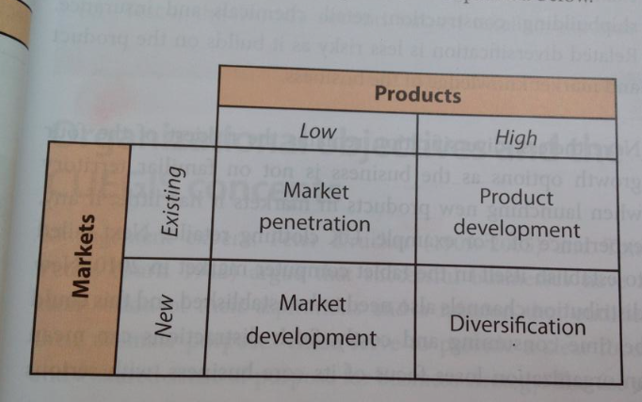

- Market Penetration
  - Sell existing products on existing markets
  - Minimize market research expenditure
  - Complete rival prices

- Product Development
  - Sell new product on existing markets
  - Product extension strategies: more demand
  - Brand develops

- Market development
  - Sell existing products in new markets

- Diversification
  - New products in new markets
  - Becomes a:
    - Holding company: owns other business/shares (parent company)
    - Subsidiary: company controlled by holding company

  - Two Categories:
    - Related Diversification: wants new customers within same company
    - Unrelated diversification: new products on untapped markets

Organizational Objectives
- S - pecific
- M - easurable
- A - easurble
- R - ealistic
- T – ime constrained
1.4 Stakeholders

Stakeholders: person /org. interest & affected by a business

- Internal Stakeholders: members of organization (employees, managers, directors)
  - Employees: strive for better pay, produce goods & services forsale
  - Mangers & directors: aim profit maximization
    - Oversee daily operations
    - Executives elected by shareholders to direct business
  - Shareholders: invest money by purchasing its shares
    - Maximize divide (higher profit)
    - Capital gain (rise in share price)

- External Stakeholders: not part of a business but have an interest/involvement
  - Customers: market research
  - Suppliers: raw materials, maintenance

  - Pressure Groups: place demands on org.
    - Boycotting: not buying the product adverse publicity
    - Lobbying: demand to gov.
    - Public relation: positive publicity for awareness
    - Direct action: mass protest

  - Competitors: rival business of an org.
    - Remain competitive
    - Produce new products
    - Benchmark performance: compare key indicators
    - Key performance indicators: progress towards strategic goal, market share figures, turnover (the one that sells it faster)

  - Government
    - Check on unfair business
    - Corporate taxes
    - Safety & health
    - Lowers interest rates/taxes: create employment & investment

Stakeholder conflicts
- Can’t meet all needs of all stakeholders
- Remuneration: pay for work/service

Key issues:
- Type of org.
- Aims & objectives
- Source & degree of power – being replaced by competition

Mutual benefits
- Addressing need of employees & managers
  - Productive workforce
  - Lower staff turnover
  - Improve profits

Stakeholder & CUEGIS
- CUEGIS: change, culture, ethics, globalization, innovation & strategy
- Business can’t fulfill aims of ALL stakehlders

Stakeholder Mapping:
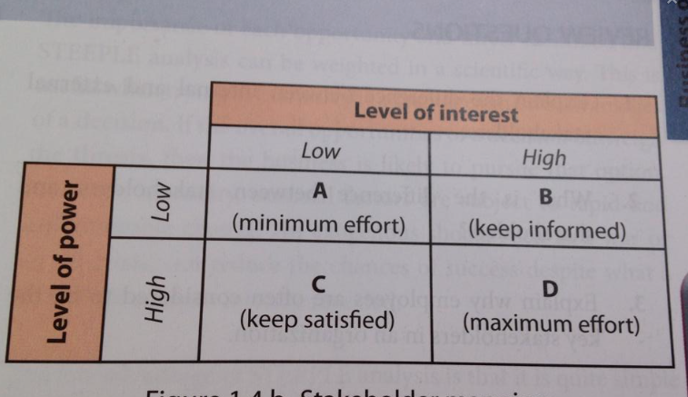

1.5 External Environment

STEEPLE: Social, technological, economic, environmental, political, legal & ethical
- Affect all business
- Can’t control any person or organization (external factors)

Opportunities: external factors give a chance for business (lower tax rates)
Threats: external factors damage business (oil crisis)

1- Social
- Support for environment + protection
- Flexible labor force
- Multiculturism – more choice
- Social pressure groups – more ethical
- Demographic changes
- Language – creates opportunities

2- Technological
- Advance tech – improve productivity
- New working places – internet (home)
- Cost a lot
- Loose jobs (distraction)
- Price transparence: accessibility of the order flow of a particular stock

3-Economic

- Control Inflation
Consumption Price Index (CPI): calculating inflation
- Inflation: rise of prices
- Cause: excessive aggregate demand (more demand for product product has higher price), high production cost, value of currency
- Effect: higher consumption, investment, gov. spending, international trade

- Reduced unemployment
- Unemployment poverty & high crime levels increase tax payers gov. spends on welfare for unemployed low international competiveness

- Gov. Lowers corporate taxes & interest rates encourage business

Types of unemployment
- Fractional: change of jobs
- Seasonal: reoccurring changes in demand
- Technological: labor saving tech.
- Regional: unemployment rates in regions
- Structural: demand of product falls
- Cylical: lack of economic demand – price is too high

- Economic Growth
- GDP: change in economy’s total output value per year
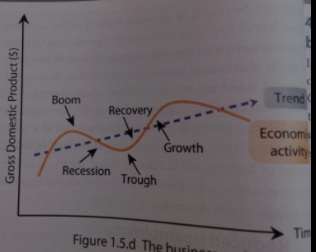

Business Cycle
- Boom: high economic activity, low unemployment
- Recession: fall in GDP, high unemployment, low investment, falling export
- Trough: bottom of recession, last decline
- Recovery: GDP recovers from trough

Barriers for economic growth
- Lack of infrastructure: transport, communication

Recovery
- Cost Reduction – cash flow: better suppliers, cut light/energy
- Price reduction
- Non-pricing strategies
- Branding
- Outsourcing: overseas

- Healthy international trade balance
Records value of country’s export earning & import expenditure
- Balance: not a high export earning
- Balance exchange rate: value of domestic currencies in foreign currencies
- Higher E.R higher export prices
- Lower E.R. price advantages for domestic firms
- Imbalance E.R. limit accuracy on exporting

- Protectionist measured: gov. policy safeguarding domestic businesses (business in home country & pay tariffs)

Solution:
Protectionist measures: gov. policy to safeguard domestic business from foreign competitors

- Tariffs - tax to be paid on imported products domestic firms price advantage

- Quotas – quantities limit on value/volume import

- Subsidies – financial aid by Gov. to business reduces cost of production competitive advantages

- Embargos – physical bans on international trade (countries)

- Technological & safety standards: regulations on imported products raises production cost on foreign countries

4- Environmental

- External cost: cost incurred by society, not people
-Impact reputation

5- Political
- Stability – taxation & interest rate policies

- Laissez-fair government – gov. intervenes as little as possible in economic affairs

- Interventionist (opposite): adopts free market legislation + policies manages economy (sets prices) influences domestic economy/business activity healthy competition

  - Deflationary fiscal policy: reduce aggregate demand (demand of the GDP of a country to reduce price inflation and economic activity)

Fiscal Policy: the way the gov. handles economy (interest rate, exchange, inflation, regulations)

    - Deflationary monetary policy: regulation of money supply & interest rate by a bank to control inflation and stabilize country (more business activity)
-Limit the amount of $ in the market prices not as high
Higher Interest Rate= more demand on currency, more investors

    - Expansionary fiscal policy:
-taxes reduce: less to gov., more to business
-public sector spending increase: business receive more money they produce what the gov. needs

    - Deregulation: remove gov. rules & regulations (bureaucracy) no business activity constrains & increase in competition

    - Corruption

6- Legal

Common legislation affecting business
- Consumer protection legislation: Law for false/misleading product descriptions

- Employee protection legislation: prose interest & safety of workers (anti discriminate, equal pay, health, safety, min. wage)

- Competition legislation:
  - Anti-competitive practices prohibited
  - Protect consumers/small business from firms with monopoly power
Monopoly power: single company owns nearly all the market

7- Ethical

Good Quality:
- Min. wage
- Good working conditions
- No mislead market
- No corrupt suppliers

External social audits: reports on ethical & social stance of business

External Env. & CUEGIS concept
- Helps decision making on:
  - Potential cost
  - Market planning
  - Business proposition (expand)
  - Investment

Firms Gearing: extent to which business relies on external borrowing (interest rate)

1.6: Growing & Evolution

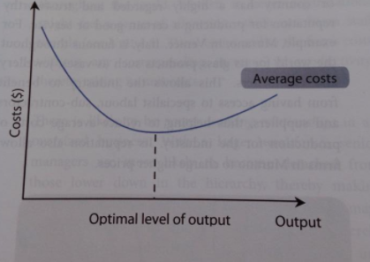
Economies of scale: lower avg. cost of production as firm operates on larger scale
  - Productive efficiency
  - Cost advantage: more profit

Average cost (AC): cost per unit of output
Total cost (TC) / output quantity (Q)

- Average fix cost: total fix cost/Q

- Average variable cost: AVC / Q

Internal economies of scale: That occurs in firms & has control

Lowering avg. cost of production by:
- Technical economies: use machinery to mass produce their product

- Financial economies:
  - Larger firms are less risky lower rates of interest for borrowing $
  - Smaller firms: struggle for external finance higher interest rate

- Managerial economies: divide roles of management
  - Sole trader becomes group divides roles
-Gerente

- Specialization economies: division of labor of work force
-McDonalds: cortar tomates

- Marketing economies: if bigger business publicity is same advert in lots of countries

- Purchasing economies: buying bulk resources (bigger discount)

- Risk-bearing economies: conglomerates: minimize risk (have other different business)
-interbank: plaza vea, inkafarma, etc.

External economies of scale: benefits outside business

- Technological progress
- Improved transportation network: ensures deliveries
- Skilled labor: government aided training programs, education facilities

Internal diseconomies of scale: higher unit costs as firms size increases

- Managers lack control & coordination
- Poorer working responsibilities: damadged communication, avg. cost of production increases
- Slack: get bored of repetitive task – low efficiency
- Bureaucracy increase: lack communication
- Complacency: reduce productivity

Solution: Franchising – licensed granted by company to trade using firms name, logos, product brands & trademarks (names)

External diseconomies of scale:
- Increase market rents: too many business on certain area – unit cost raise
- Offer higher wedges/financial reward:

Organizations
Size of a business measured by:
- Market share: firms sales revenue as % of industries total revenue

- Total revenue: value of firms annual sales turnover per time period

- Size of workforce: employees

- Profit: value of firms profit per time period

- Capital employed: value of firms capital investment for business to function

Large | Small
Brand recognition | Cost control – the cost of opening a new place is not worth it (extra borrowing, control problems)
Brand reputation | Financial risk
Value – added serviced | Gov. aid – grants/subsidies/training
Lower prices – economies of scale | Local monopoly power
Greater choice | Personalized services – devote to customers
Customers loyalty | Flexibility
 | Small market size – low competition

- Optimal size: depends on structure, cost, aims & objectives
- Growing allows: more profit, financial resources & economies of scale
Internal (Organic) Growth
- Business grows using own capabilities/resources
- Increase sales revenue & scale of operation

Effects
- Change prices
- Promotion
- Better products
- Placements – greater distribution
- Offer preferential credit – buy now pay later
- Increase capital expenditure: investment
- Improve training
- Provide value of money –quality vs paid

Advantage | Disadvantage
Control & Coordination | Diseconomies of scale – higher cost production
Inexpensive – retained profits from low capital | Re-structure
Corporate culture | Dilution of control & ownership – shareholders now decide
Less risky | Slower growth

External (Organic) Growth

- Mergers & acquisitions

Merger:
- 2 business integrate 1 larger market & economy of scale

Acquisition:
Takeover: company buys more than 50% becomes owner of the company

- Horizontal Integration: combining firms to operate on same industry
Gloria buys Laive

- Vertical Integration: business at different stages of production have same end
Buys suppliers/Clients Gloria: buys vacas & wong

- Lateral Integration: firms with similar operation but no competition
Cineplanet: buys popcorn & movies

- Conglomerate Integration: integration of completely distinct market business
Interbank: owns Bembos, Cineplanet, Seguros
Reasons:
- company lacks fund for internal growth
- small rivalry, financial crisis
- low profit & share price: easy target
Effects
- Redundancies – job loss
- Conflict / culture clash
- Low control

2. Joint Ventures
- 2+ business split costs/risk/control & rewards for a business project

Advantages
  - Synergy: greater outcome
  - Spreading costs & risks
  - Entry to foreign markets
  - Relatively cheap
  - Competitive advantages
  - Exploitation of local knowledge
  - High success rate

3. Strategic alliance
- 2* cooperation in business venture remain independent work for mutual benefit

Advantages
  - Gain synergies
  - Added value service
  - Wider distribution

Stages
  - Feasibility study: investigate, rational objectives
  - Partnership assessment
  - Contract negotiation
  - Implementation

4. Franchising
- Franchisor (parent company) receives license fee & royalty payment (commission) from franchisee (purchaser) to trade/distribute firm’s name logo, brand & trade marks

Advantage | Disadvantage
Rapid & cheap growth of franchisor | Risk to damaged reputation
National/international presence | Slower than M&A’s
Low risk of un-success | Regulated by franchisors qualities standards
Low start-up cost | Franchisee pays high revenue percentage of franchisor

Role & Impact: GLOBALIZATION

Globalization: growing integration/interdependence on worlds economies

- Increase competition
- Customers expectation/base
- Economies of scale: global market & risk-bearing economies
- Greater location of choice
- External growth opportunities
- Increase finance source

** risk-bearing economies: the larger the firm – the more risks & investments it can make

Multinational Companies Growth
- Organization operations in 2+ countries
- Intensify globalization
- Head office on home town

Transnational company: regional head offices

Reasons to MC:
- Increase customers base
- Cheaper production cost – inexpensive labor
- Economies of scale
- Protectionist of policies are avoided – tarriffs, quotas, restrictive trade practices

Advantage | Disadvantage
Create jobs | Cause unemployment
Boost GDP through consumption expenditure | Profits are repatriated (Sent to home country)
New skills & tech | Social responsibility
Competition | Competitive pressures – forced to raise $
 | Takeover domestic business

Growth & Evolution: CUEGIS
- Greater profit & sustainable competiveness
- Cultural, change, globalizations

Strategies
- Have a good reputation
- Unique selling point
- Branding
- Economies of scale
- Diversification – sell new products in new markets
- Brand acquisition - buy brands
- Demerging – sell part of a business
  - Diseconomies of scale is avoided
  - Sustain operations
  - Avoid raising unit cost

