4.1 - The role of marketing

- Marketing: address peoples needs & wanted
  - Needs: essential necessities
  - Wants: human desire

Objectives:
- Right products supply needs & wants
- Correct price – affordable
- Distribute conveniently
- Adequate & effective promotion

Roles
- Management process – responsibility for decision making
- Identifying needs & wants of customers
- Anticipating wants of customers
- Price, availability & quality
- Earning profit (or slurps)

Other business functions
- Operations management
  - Production department
  - Uses sales forecasts for production schedules
  - Research, develop & launch products to meet changing needs

- Finance
  - Set appropriate budgets –
  - Conflict: markets wanting to exceed their budget for max. Exposure
    - Marketers might use: extended credit facilities – interest-free repayment plans
    - Can lead to liquidity problems

- Human Resources
  - Marketing data – identify staff needs
  - Having right quantity & quality
  - Require new hiring: extra production staff / sales personnel

Marketing goods & services
- Similarities: use promotion brand recognition, awareness, trust

Difference

 | Services | Goods
Intangibility | Intangible | Tangible (physical) – can inspect before buying
Inseparability | Consumed at the times of the purchase | Customer services – can’t separate consumption & production
Heterogeneity | Experience is different for different costumers (hetero) | Mass produce standardized (homo) goods
Perishability | Can’t be stored – may face loss in revenues | Durable to some extent
Product strategy | Value-added services – attract customers
Price Strategy | Based on time spend on providing the service/level of skill required | covers cost of production + profit
Promotional Strategy | Challenging (its intangible) use physical environment | The use of branding, slogans, logos & celebrities endorsements
Place Strategy | Customers convenience | Can be ordered online – effective distribution channels

Market & Product Orientation

Market Orientation
- Making products that they can sell
- Focus: Identifying, designing, developing & supplying products meeting customers needs/wants
- Market Research & Analysis
  - Create desirable product, right price, promotion, places

Advantages
- Greater flexibility: firms respond quickly to changes in the market
  - Have relevant data
  - Anticipate for such changes

- Lower Risk: confidence on selling product

Disadvantage
- Expensive Market research

Product Orientation
- Selling the product that they make
- Innovative & creative products are tempting
- Focus: producing HQ products
- High failure rate frequent changes in fashion/taste
- Don’t take customers in consideration

Factors choosing Market/Product Orientation
- The market
- Organizational culture – (market: believing customers are key stakeholders)
- Barriers to entry – competition level
  - Less: product-orientated

Commercial marketing & social marketing

Commercial Marketing
- The use of marketing strategies to meet the needs/wants in a profitable way
- Value free – low role on ethics
- Providing what they want, when they want it, where they want it

*Aim: Reap private benefits of marketing such product

Social Marketing:
- The planning & implementation of programs designed to bring social change
- Informing the public about dangers, aids awareness, anti-smoking/drinking

- Market Research: discover peoples behavior, perception of issue
- Process: donating money to charity, tax benefits
- Price decisions: net benefits: cost of taking action – benefits

Difference

 | Commercial | Social
Purpose | Selling physical goods & intangible services for profit | Influence/persuade a desired change in behavior
Benefits | Satisfy needs and wants profits | Satisfy needs and desired of general public community benefit
Main users | Private sector business | Gov./non gov. org  (companies believing in corporate social responsibility enhance image)

The Market
- Market: place where customers & suppliers trade
  - Where there’s: demands for product & business to supply

  - Consumer markets: cater for private individuals (general public)
  - Industrial/producer markets: cater for organizations (business/gov.)

Characteristics
- Market Size – measured by sales revenue
- Customer base – total potential # of customers
- Barriers to entry – obstacles determine # of suppliers
(high set-up cost, competition, economies of scale)
- Competition – rivalry within particular market
- Geographic characteristics – focused on particular area, country, region
- Demographic characteristics – difference in gender, age, ethnicity & religion
- Market growth rate – the increase in the size of a market per period of time (yr)
  - Measured: increase in the value/volume of sales (%)
  - Leads to more suppliers
- Seasonal & Cyclical characteristics –

Market Share
- Organization portion of total value of sale revenue within specific industry
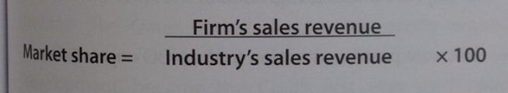

Benefits
- Dominant market player
- Market Leaders: Ability to gain a range of economies of scale
- Better price setting ability
- Less competition

Increasing market share by:
- Promotion of brand
- Product development, improvement, innovation
- Workforce training & motivation
- Establish property rights
- Efficient channel of distribution

Market Concentration: the degree of competition that exist within a market
- Dominant firms large portion of industry sales revenue

- Calculate market share of largest few firms in industry
- Concentration ratio: sum of market shares

Marketing Objectives
- For businesses aiming profit
- Non-profit org. – religion, charities, org.
- Gov – advert. Income tax returns

Factors for aiming profit:
- Increase sales revenue- increase customers base / to buy more
- Higher market share – more competitive
- Increase market leadership – business enjoys benefits of largest market share in industry
- Improve product & brand awareness – promote product
- Developing new products – gives competitive edge
- Enhance brand perception – positive product positions (opinion)

Factors for NPO:
- Build support for new donors
- Generate awareness
- Improve brand recognition
- Positive attention
- Demonstrate values to local community / society
- Informative

Marketing strategies & changes in customer preferences
- Market trends change rapidly
- Having insight in customers buying habits, preferences & how they change

Reasons why marketing strategies evolve
- Changing customers tastes
- Shorter product life cycles – maintaining sales growth (need extension strategies)
- Internet & mobile tech.
- Competition rivalry – reduce threat in profitability & survival
- Globalization – adapt to suit varied local preferences / cultural norms

Marketing & CUEGIS
- Unethical marketing – moral codes and practice not adhered offense
- Understanding market where business operating develop appropriate business stragues

Misleading/unethical marketing techniques
- High-pressure sales - hooking into a deal and switching it before pay
- Product misrepresentation - using similar brands
- Exploitation of weakness – ‘limited’
- Unsubstantiated claims – unproved market claim (4 out 10….)
- Pester Power – using children to harass parents (to buy the product)
- Confusion marketing – excessive price info. (bank mortgage deals)
- Health/Travel fraud – untested scientific info

Ethical Code: business abide to certain guidelines & rules for ethical market
Functions
- Identify acceptable business
- Internal manag. & control
- Avoid confusion
- Informing, reminding & persuading
Innovation
- Internet to market, promote

  - – Marketing planning
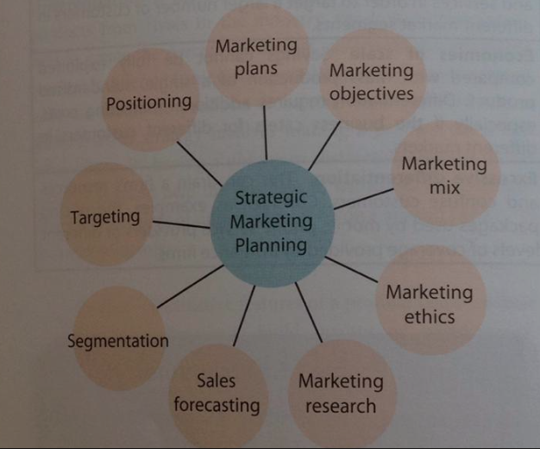
Elements of marketing plan
- Outline of a firm’s marketing objectives & strategies
- SWOT & STEEPLE
- Improve firms chance of success
- Key role: allow marketing managers to have better control of org.

Market plan process
- Marketing audit - review of current position of a firm’s marketing SWOT (strength, weakness, opportunities, threats competition, portfolio)
- Marketing objectives – goals & targets
- Marketing strategies – marketing mix
- Monitoring & review – targets being met
- Evaluation

Market Plan details
- Marketing objectives SMART: specific, measurable, agreed, realistic, time constrained
  - Expected market share
  - Sales turnover
- Assessment of strength & weaknesses of competitors
- Outline market mix - distribution, product design, price, promotion
- Marketing Budget
- Anticipated difficulties/strategies

Limitations
- Small firms have no time, resources, expertise
- React to marketplace (not anticipate)
- Devote time, people, money

The 4 Ps: Market Mix

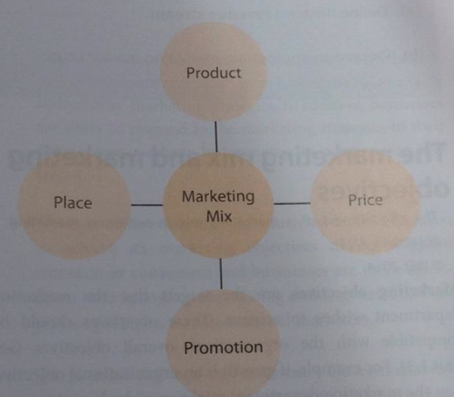
Market Mix: The combination of elements needed to successfully market a product
- Review & develop market strategies
-Product
-Price
-Place
-Promotion

Product
- Physical good or intangible service fulfilling needs/wants
- Produce Products: industrial products dolt to other business for production process
- Consumer Products: sold to the end user
  - Convenience products: food products, consumer durables (long lasting), specialty products (expensive)

Price
- The amount that customers pay for particular good/service
- Depends on
  - Demand
  - Rivalry
  - Aims: maximizing profit or NPOs
  - Supply: lower supply higher price
  - Time: may be replaced by new generation
  - Image
  - Cost of production

Place
- Distribution Channels
  - Manufacturer wholesalers retailers consumers
- Deliveries, internet
- Fewer intermediaries – lower the price

Promotion
- Strategies used to attract customers to buy firm’s product
- ATL Promotion: paid-for mass media (t.v., radio, newspaper)
- BTL Promotion: all other (packaging, sponsorship, viral)
- Promotional Activities
  - Advertising
  - Sales promotion – price reduction, gift cards, free gifts
  - Sponsorship
  - Publicity – getting good press (media) coverage (famous)

The Marketing mix / Objectives

Marketing Objectives
- The targets that marketing wishes to achieve in a profitable way
- Compatible with org. objectives
- SMART: specific, measurable, agreed, realistic, time constrained

Importance
- Provide purpose, direction & motivation for marketing department
- Monitored progress & success
- Help planning / development of marketing mix & strategies

Objectives
- Market share – through market penetration strategies (1.3) increase salves revenue & profits
- Market leadership – strives for greatest market share in country
- Product positioning – improve corporate image & perception by consumers
- Consumer satisfaction – by the price, product quality, customer service
- High market standing – firms presence in marketplace (based on reputation & image)

Strategies
- Market development – selling existing products in new markets (internationally)
- Product development – selling new products in existing markets
- Diversification – marketing new products in new markets (financially stable markets)
- Product innovation – original product onto the markets gain first-mover advantage

Marketing of services

P’s: Product, Price, Promotion, Place + 3
- People: personnel used
- Physical environment: aspects of service (hygiene)
- Process: how it’s provided/delivered

Limitations
-External: beyond firms control
-Internal: control of the business

- Finance – budget
- Cost of production – firms cost, economies of scale, compete on price/quality
- Size & Status of firm
- Social issues – social acceptance
- Time lags – delay on marketing activities (expenditure) & impact cause short term liquidity problems
- Actions/Reactions of competitors – might launch new product
- State of the economy – global recession, exchange rate limits spending
- Political & legal env.
Target markets & market segments

1- Market Segments: distinct group of customers with similar characteristics wants & needs
- Easy to analyze which segment buys the product
Consumer’s profiles: the demography & psychographic characteristics of consumers in different markets
- -Age, gender, occupation, income level, etc.

Reasons for Market Segmentation
- Understanding of customers
- Higher sales – wider range of costumers sell more products + profit
- Growth opportunities – identify new opportunities
- Support for product differentiation – spread its risk

Types
- Demographics
  - Age, gender, race & ethnicity, marital status, religion, language, income and socio-economic class (spending patterns)
- Geographic
  - Location – different culture & social attitudes (religion, race, language)
  - Climate – clothing
- Psychographic
  - Hobbies & Interest
  - Values – beliefs, morals, principles
  - Religion
  - Status
  - Culture

DAMAS: assessing successful market segmentation
- Differential – unique segments
- Actionable – provide suitable products
- Measurable – size & purchasing power of each seg.
- Accessible – reachable
- Substantial – generate profits

2- Targeting: each distinctive market segment having its own marketing mix

Niche Marketing: Targets a specific, well-defined market segments
Mass Marketing: undifferentiated marketing, ignores targeting individual market segments

 | Niche | Mass
Advantages | Better market focus | Huge economies of scale
 | Less competition higher prices, profits | Single market campaign (no need to modify marketing strategies)
 | Highly specialized in meeting needs/wants | Bigger customer base more profits
Disadvantages | Limits # of potential customers | Not suitable for all business
 | Fewer opp. To exploit economies of scale | Competition – high marketing budgets
 | Endanger survival of business | Wasteful – specific customers not targeted

Position (perception) map
- Reveals customer perception of a product /brand in relation to others in the market
- Identify gaps in product portfolio
- Help refine market strategies
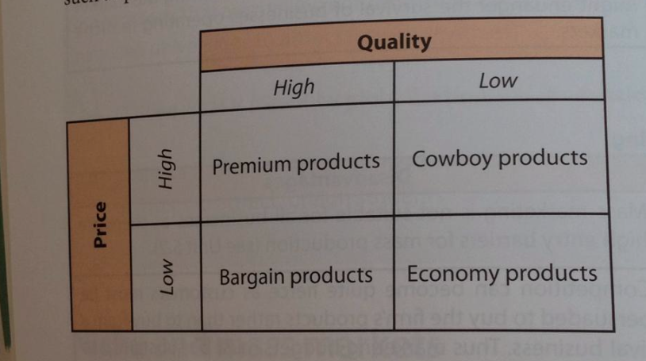

- Premium Products – HQ & high prices
- Economy products- LQ & appropriate prices
- Bargain products- HQ & low quality
- Cowboy products- LQ & high price

Positioning: if undesired perception exists

Stages
- Identify competitive advantage of product
- Which strength should be marketed
- Use appropriate marketing mix

Strategies
- Cost Leadership – low cost products on economy products
- Differentiation – distinct products from competition
- Focus – close attention to market segmenet

Unique selling point (USP)
- Any aspect of a business, product or brand that makes it stand out from the rest of the competitors
- Reputation for best, lowest, only business with product, in local area, popular logo

Differentiation
- Distinguishing a business/products from rivals in the industry
- Adds value compared with substitute products

Common methods
- Product – features: design, qualtity, functions
- Price – pricing strategies (4.5)
- Promotion
- Place
- People – unique, special skills
- Processes – how things are done, convenience
- Physical environment
- Packaging – colors, materials

Advantages | Disadvantages
Price advantage | Differentiation – expensive
Brand recognition & loyalty | Economies of scale <<- WHAT pg. 361
Distribution advantage | Excessive differentiation

Marketing Planning & CUEGIS
- Adapting to change – fashion, technology, economy
- Ethical marketing – social & moral responsibilities of marketing planning
- Technology – market research is cost effective, innovative, fasters
- Strategically – positioning, targeting, segmentation

Tools:
- Perception mapping
- Ansoffs matrix (1.6)
- SWOT analysis (1.3)
- STEEPLE (1.5)
- Foce field analysis (1.7)

4.4 – Market Research

Market Research: marketing activities to discover the opinions, beliefs & preferences of potential/existing customers

“Will customers like to buy the product?”

- Ad hoc research: specific marketing problems tending to be on a one-off basis
- Continuous research: regular & ongoing bases

Purposes
- Up-to-date info to business
- Allows improvement on their marketing strategies
- Assess customers reactions to new products
- Understand activities & strategies used by rivals
- Allows prediction, trends

Primary market research
- Involves gathering new data from customers to identify buying patterns & anticipate changes in market trends

Types:
- Surveys
  - Self-completed survey
  - Personal survey – face to face
  - Telephone survey
  - Online survey
  - Postal survey

*Should: avoid biased, jargon (technical language), closed & open-ended questions, be tested, collect relevant data

- Interviews
  - Non-quantifiable info.
  - Investigate views
  - Time consuming

- Focus Groups
  - Small discussion – share consumer profile
  - Ask questions or give feedback
  - Consumer panels: small groups of consumers within a business target market (remain the same)

- Observations
  - Under laboratory or life situations
  - Record people’s actual behavior
Secondary research
- Collection of second-hand data & info. That already exists
- Internal: info gathered by organization before (sales records, annual reports)
- External: outside business (academic journals, gov. publications)

Types
- Market Analysis
  - Characteristics & outlook (trends) of product/industry
  - Compare to rivals to formulate business plans
  - Found in: commercial sources & public info. Sources:
    - Market research firms
    - Competitors
    - Trade publications
  - Market size, market share, market growth rate

- Academic journals
  - Periodical publications from educational & research institutions
  - Distribute theoretical work & market research findings

- Government publications
  - Population census, social trends, labor market developments, trade statistics, unemployment figures, inflation rate, etc.

- Media articles
  - Newspaper, documentaries, journals, world wide web

- The Internet
  - Provides range of invaluable data

Ethical consideration of market research
- Not to access confidential data for personal gain
- Needs to be systematic, consistent, unbiased
- Laws to ensure relevant guidelines

Unethical market research (5 Ds)
- Damage – protect the people that gave info.
- Deceitful – be trustworthy: not sharing info., plagiarism, not referencing, open on procedure
- Deceptive – secretly recording collection of data
- Disclosure – invasion of privacy (customers privacy rights)
- Detachment – not personal biased, objective in their work

Qualitative & quantitative research

Qualitative: non-numerical answers & opinions
- Understand behavior, attitudes & perceptions of customers, employees
- Explore driving & restraining forces
- Inexpensive

Quantitative: larger # of responses to get factual & measurable info.

Sampling methods
- Population: all the potential customers of a particular market
- Sampling: selecting a small group of the population for primary research purposes

Methods:

Quota sampling:
- Certain number of people from different market segments is selected
- Relative representative sample is obtained (not always so good)

Random Sampling
- Giving everyone in a population a change of being selected for the sample
- Minimize bias samples
- It’s indiscriminate – not the target group

Stratified sampling
- Involves strata: subdivision of hetero population into segments with homo characteristics
Chooses # of respondent from each stratum proportional to population & randomly selects them
- There’s stratified random sampling: samples representing particular market segments being random

Cluster
- Feedback from respondent involves too much time, travelling, money
- It is quicker, easier, cheaper
- Very bias – only few locations selected

Snowballing
- Individuals who then suggest other friends, family members, colleagues to increase sample size
- Its cheap, quick hold

Convenience sampling
- Uses subjects that are easy to reach
- Its quick, useful, exclude large portion of population

Results from data collection

Errors:
- Non-sampling errors: human error/behavior
  - Researchers mistake in processing, recording, analyzing data
  - Answers are not honest

- Sampling errors
  - Sample size is to small, not representative
  - Inappropriate sample method
  - Biased research

Representing data in
- Bar charts
- Pie chart
- Line graphs
- Histograms

Limitations
- Unreliable input data generate poor quality output info (GIGO)
- Bias
- Cost of good market research is high

Market research & CUEGIS
- Culture: understand cultural differences to conduct their research
  - Cultural sensitivity – acceptance of things
- Ethical issues: not passing info to third parties
- Globalization: research is integral to business strategy (brand recognition)
- Technology innovations: easier market research

  - – The four Ps

Product: any good/service serving to satisfy the needs or wants of customers & offering value for money (sales revenue)
- Tangible: physical products
- Intangible: services

Consumer Products: purchased by individuals
Producer Products: goods purchased for commercial use (for production process)
Fixed assets:
Land, machinery, tools, vehicles

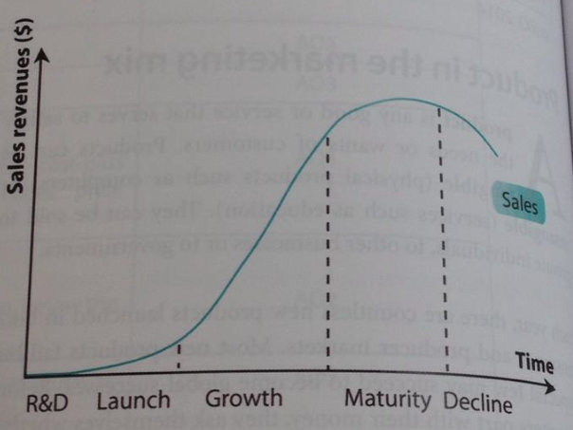
Product life cycle
- Different stages that a product goes through
- Life cycle: measured over time (sales revenue)

1. Research & development stage
- Designing & testing the product
- Prototype: trial product
- Test Marketing: trialing the new product with sample consumers to gather feedback
- Minimize costs if product is unsuccessful

2. Launch (intro) stage
- Marketing planning
- Low sales with high costs (pay for publicity, promotion, distribution) unprofitable

3. Growth stage
- Sales revenue increases
  - Greater profit
  - Lower unit costs from economies of scale in production
- Wider distribution channels
- Early adopters: customers at this stage boost sales & cash flow

4. Maturity stage
- Sales revenue continue to rise – slower rate
- Favorable cash flow & profits
- Economies of scale – competitive advantage
- Saturation: too many competitors in the market & sales peaked/fallen
- Focus on promotional activities

5. Decline stage
- Low sales, profit, cash flow, customer demand
- Change in fashion & tasted
- Investment on product is cut price plummets
INSERT TABLE PG. 394***+

Extension strategies & the product life cycle

Common extension strategies
- Price reduction- increase demand, get rid of excess stocks
- Redesigning- introducing special features adds value
- Repackaging- revive demand
- New markets
- Brand extension- using successful brand name to launch new product
- Product differentiation- Color, size, quality, design, packaging, after-sales care (guarantees), customer relations management

Boston Consulting Group (BCG) Matrix
- Helps plan for balanced product portfolio: variety of products owned by a business
  - Deciding investment, withdrawal, remarket on product
(growth strategies – 1.6)
  - Has a strategic business units: divisions of an organization
- Should be used with Ansoff’s Growth Matrix (1.3)
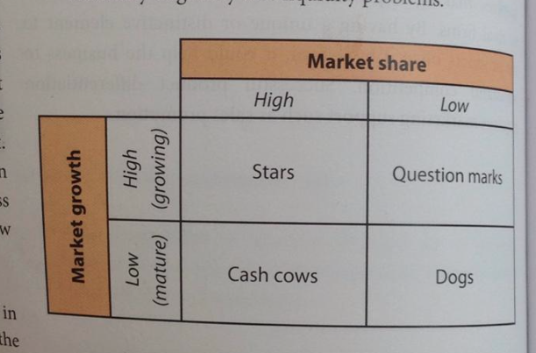
KEY
Question Marks: products in high market growth sector + low market share
  - Wild cards: not knowing if to invest

Stars: products in high growth markets + high market share successful

Cash Cow: high market share in low growth market generate high net cash flow (profit)

Dogs: low market share in low growth markets unsuccessful

-Rising star: problem children turning into stars

-Balanced Portfolio: some stars, few ?, lots of cash cows
- Allows cash flow
- Varied markets = higher revenues

Branding
- Differentiating a firms products from competitors
- It’s a legal instruments
- It’s a risk reducer – chance of survival, encourage brand awareness
- Business need to invest money to promote it
Positive factors
- Intangibility – brand sells the product
- Uniqueness
- Timeless
- Price Advantages – willing to pay for good brand (revenue earner)
- Recognition & loyalty
- Distribution advantages – vendors stock the best selling brands

Aspects of Branding
- Brand awareness – recognition higher sales revenue

- Brand development – marketing process, improving, enlarging the brand name
  - Generic brands: product name is mistakes by the brands name

- Brand loyalty – customers buying again & again
  - Helps maintain business
  - Charge premium prices for products improve profit margins
  - Entry in high competitive markets
  - Future success of a business
  - Customer loyalty scheme: sales promotion to entice customers to stick to brand and not brand switch

- Brand value - customers willing to pay for a brand name over the value of the product
  - Higher market share
  - Premium prices – feel the added value (reputation)
  - Higher barriers to entry – new firms won’t enter the market

Packaging
- How product is presented
- Impacts customer perception of a product/brand
- Acts as product differentiation
- Protects product during transportation/distribution
- Provides information – legal obligations, promotions
- Easier distribution
- Encourage impulse buying
- Promote the brand

Limitations
- Environmental effects
- High cost

Product & CUEGIS
- Functional value: what the product actually does for the customer
- Emotional value: psychological & feel-good factor
- Brand extension strategies: brand loyalty enables business to launch new products
- Marketing myopia: business become complacent about their product strategy disaster on market changes
- Multi-brand strategy: business developing 2* brands
- Product cannibalization: when brands from the same business directly compete with each other

- Globalization: multinational business have global brands (recognition)
  - Consistency of product
- Cultural & ethical: glocalized – local preferences rather than globally
- Innovation: intensified competition, continuous innovation of products
  - SWOT analysis for longer life
  - Increase product mix greater revenue + less risks

Build Market share | Questions stars by investing necessary resource  (Gain market share)
Harvest | Reaping benefits of a product  Stars cash cows  (Advertising)
Divest | Selling off dogs

The Boston Matrix & product strategy

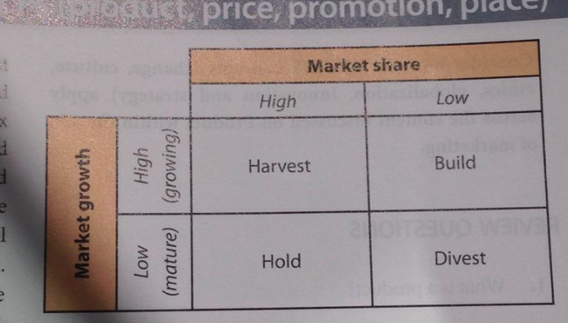

4. 5 – 4 P’s

Price
Price: the amount paid by a customer to purchase a good or service
- Too high: deters customers
- Too low: lac of stock, dissatisfied customers

Cost-plus (mark-up) pricing
- Adding mark up (profit margin): % of profit to the cost per unit of output determines selling price

Penetration pricing
- Sets a low price (special introductory price) to establish new product in industry
Gain price recognition & market share
- Used for mass products to sustain low profit margins

Price skimming
- Technologically advance & innovative product: high price is set
Recoup cost of research & development – prestigious image of product
- No substitutes = maximize profits

Psychological pricing
- Rounding down numbers to make prices seem lower ($1.99)
Feel they are getting a bargain: better price

Loss Leader
- Selling a product below its cost value
Attract customers, encourage brand switching, recoup the loss by sales through complementary goods (Nintendo sells gaming software)

Price discrimination
- Same product is sold at different prices to different customers

Conditions for successfulness
  - Market power
  - Different degrees of customers
  - Separation of markets: avoid reselling

Price leadership
- Dominant firm set its own prices
- Competitors follow the leader (limitation: not the same economies of scale)

Predatory pricing
- Temporarily reducing prices to force rivals out of the industry
- Destroy pricing: rival can’t compete profitable wise
  - Intensive price cuts

Price & CUEGIES
- Does not destroy profit margin, consistent with firms objectives

Must be consistent with
- Market planning
- Place
- Product
- Promotion

Other factors affecting
- The nature of business – profit maximizing firms use pricing strategies
- The nature of barriers to entry- competition within industry
- Business image
- Business cost- cover its cost of production
- The state of the economy- reduce prices during economic recesiion

Promotion
Promotion: methods of communicating messages to the market (selling a firms product)

Key objectives
- Informative promotions – alert about product
- Persuasive – encourage to purchase
- Reminder – retain customer awareness & interest on product

Above the line - Paid-for promotional method (mass media) | Below the line promotion - Non-mass media promotional activities  - No commission paid
Television advertising  - Combine sound & moving images  - Huge cost of production for advert. Slots | Publicity  - Getting media coverage without paying for it  - Famous celebrities using product
Radio advertising  - Radio time slots sold to business (cheaper)  - Reach large audience  - Only can communicate audio messages (no visual impact) | Point sales promotion  - The promotion of a product at the place or location where customer buys the product  (supermarket check out)
Cinema  - Audience is directly targeted  - Hard to ignore  - Limited audience size | Direct marketing  - Promotional activities aiming to sell a product  - Telemarketing (telephone calls), emails, mail  - Keeps larger share of any profits (no intermediaries to pay)  Cost of producing & distributing promotional material
Magazines  - HQ photos: attract attention  - Advertisement clutter: readers bombarded with advert. may be ignored  - Long submission process, competition | Sales Promotions  - BOGOF: buy one, get one free (get rid of excess stock)  - Money-off coupons  - Free samples of products  - Competitions to win prizes  - ‘Free gifts’  - Customer loyalty schemes (Rewarded for buying)  Boost sales but add to marketing cost
Outdoor advertising  - Commercial billboard, banners, posters  - Tech: rotating billboard = larger audience, high exposure  - Hard to monitor effectiveness | Word-of-mouth promotion  - Spread of information from person to person
Newspaper advertising  - Target different markets better  High cost, difficult to stand out | Sponsorship  - Business providing financial funds & resources to support event/org. in return for publicity
 | Packaging
Slogans: catchphrases to retain attention
- Effectiveness: MAID – memorable, advantages (of product), image, desire

Direct mail
- Mailing promotional material to customers
- May see as junk

 | Branding: recognizable

Promotional mix
- Tools to communicate benefits of product

Deciding a promotional mix by: AIDA
- ATTENTION – raise awareness of product
- INTEREST – using sales promotion, slogan
- DESIRE – feeling of need for product
- ACTION – customers buy the product

*Or use FAB: Features, Advantages, Benefits

Factors to consider:
- Cost – cost per head: cost of promotion / by the potential audience size
- Product
- Product life cycle
- Legislation

Key elements to a promotional mix
Advert. Techniques
-Bargain appeals: good deals
-Celebrity endorsement
-Comparative
-Direct response: contact details
-Feel food factor
-Guarantees: promising
-Numerical/Scientific claims

- Advertising
- Personal selling - Sales representative directly persuading customers to buy
- Public relation – establishing & protecting desired image of an org.
- Sales promotion – stimulate demand for product

Technology & Promotion
- Viral Marketing (P2P): relies on electronic transfer & spread of promotional messages

Social media marketing – the TOOL
- Gaining internet traffic through social media website
- Comes from trusted third party (friend, family)

Social networking – HUMAN INTERACTION
- Any platform used to build social relationships between people
- Share information on product
- Web banners: advert. On web page
- Search Engines: sponsor link when typing a word/phrase

Guerrilla marketing
- Not only invest on money for promotion but on time, energy & imagination
- Makes target feel unaware that they’re targeted
- Automobiles, Bagvertising, Bravertising, Fuzz marketing (WOM), Graffiti, Lavatories

Advantages | Disadvantages
Marketing activities generate 80% firms revenue | Large opportunity cost – time & resources
Lead to viral marketing | Controversial & unethical methods used
Inexpensive | Not always reach the target
Promote creativity & healthy competition | Not always work
Promotion & CUEGIS
- Ethical: laws must be obeyed, social responsible, spending
- Depends on the creativity of marketers

Place
Place: distribution of products
- Requires management skill: persuading retailers to stock a firms product
Retailers: cinemas, supermarkets = limited space

Channels of distribution
- The means used get a product to the consumer
- Intermediation: process to facilitate this
- Intermediaries: agents/business that act as middle person in the channel of distribution (between manufacturer & consumer)

Levels of distribution
- Zero-level channel: no intermediaries
Producer consumer (mail)

- One-level channel: 1 intermediary
Producer retailers/agents consumer

- Two level channel: two intermediaries
Producer wholesaler’s retailers consumer

Types

Wholesalers
- Business that purchase large quantities of products from manufacture break the bulk-purchase into smaller units for resale
- Bear cost of storage, sell smaller batchers of product, lower transaction cost, roles distributed

Distributors & agents
- Distributors: independent & specialist business that trade in the products of only a few manufacturers
- Agents: negotiations who act on behalf of buyers & vendors of a product
  - Charge commission

Retailers:
- The sellers of products to final consumer
  - Independent retailers – local vendor (sol propitiator)
  - Multiple retailers – numerous outlets
  - Supermarkets
  - Hypermarkets - huge outlets with broad range of products
  - Department stores – retail outlets selling large range of products
Specialty channels of distribution
- Indirect way to distribute product not involving retailers (no intermediary)
- Greater business profit, direct control of distribution, internet use

Types
- Telemarketing – telephone systems
- E-commerce – trading via the internet
- Vending machines – stock products for sale
- Mail order & direct mail – promotional material

Place & CUEGIS
- Choosing the best channel, assuring intermediaries stock firms products
- The product, the market, time, legal constraints, cost & benefits
- Globalization: wider distribution
- Exportation external constraints: fluctuating exchange rates, gov. intervention, language barriers, cultural difference
  - Cultural difference: products not suited for all regions

4.8 E-commerce

- E-commerce: trading of goods & services via the internet, electronic systems & computer networks.
  - Operate 24 hours a day
  - Online trading opportunities

Examples
- Financial services
- Gamins
- Retailing

Features
- Global Reach: sell products to consumer in any part of the world
- 24/7 accessibility: accessible at all times
- Access to information: provide detailed & accurate product info. make informed buying decisions
- Consumer reviews: post online reviews impacts on buying decision
- Impersonal interaction: B2C firms reach customers with tech
- Barriers to entry: e-tailer are cheaper than physical retailer easy entry

E-commerce & marketing mix

Types of E-commerce

- Business to Consumer (B2C) selling directly to end user
- Business to Business selling directly to business customers
  - TESCO (supplier to business)
  - Professional buyers
- Consumer to Consumer consumers selling to each other
  - EBAY

- Consumers

Benefits | Costs
-Lower Prices  -More convenient (home delivery, downloads)  -Access customer reviews  -More choice | -Not everyone online  -Cannot “see” the product  -Online Fraud  -Cookies! (know who you are)  -Spam

- Companies

- Benefits | - Costs
- -Lower Costs (no stores)  - -Worldwide Market (Economies of scale)  - -Possible USP | - -Set up costs  - -Possible Hacks  - -Increased Competition  - -Unhappy customers can damage brand easily

Products
- Products that are now online Decline Stage (Of product life cycle)
  - Camera
  - Magazines
  - Music
  - Casino
  - Calculator
  - Flashlight

  - Calculator
  - Board Games
  - Calendar
  - Maps, GPS;
  - Computer Games

Link #1: Decline Stage old ones

Link #2: Use your money for cash cows to use for stars (itunes money investing on beats)

- Promotion online
- Reduced storage cost no need to stok/display
- Marketing strategy: see demand of products
- Less investment on packaging reduce overall cost higher profit margins for business/reduced price for customers
- Product specification given

Price

Same product, cheaper prices
  - Economies of scale high output, low avg. cost
  - Competition
  - Offer value for money

Changes in place
  - lower cost rise unemployment

Technology
- Increase prince transparency consumers can compare
- Enforces pricing strategies to maintain market share
- Set according to demand

Intermediaries cut out
- Such as wholesalers & retailers
- Sell directly to customers
- Lower cost lower price

(low percentage mark-up per intermediary)

International Trading
- Postage & shipping cost
- E-commerce aware of international trading standard & regulation
- Add to their costs
- Currency flow problems paying can cause fall in the vale of its exchange rate

Promotion

Social Media
  - Yahoo
  - Gmail
  - Pop-up
  - Tinder
  - Myspace
  - Hi5
  - Flickr
  - Google +
  - Tumblr

  - Facebook
  - Twitter
  - Instagram
  - Snapchat
  - Yahoo
  - Myspace

- getting feedback, customers are the users
- spreading information

- Online marketing greater details of products (BTL)
- Viral Marketing – Word-of-mouth with social networs
  - e-mails: cost-effective, undersirable
- Online sales channel supports need of international community

Place (distribution)
- Reaches global audience
- Fuelled competition potential enormous customer base
- Shorten channel of distribution
- Customers convenience
- Allows language translation increase customers
- Not-For-Proftit org. (univiersities) ebooks
- Limitations: un-willingness to purchase product by lack of examination

Benefits
- Source of revenue advert- spaces on their webpages
- Channel of distribution sell any time of the world & time
- Greater flexibility respond quickly to competitors
- Reduced packaging’s
- Higher overheads
- Reduced operating costs online bills, free supplying costs
- More choice & convenience

The cost of e-commerce
- High Set-up costs specialist to set up & market websites
- Running costs packaging, distribution
- Credit Card finance charges for using their payments
- Fraudulent trade identity thief & online frauds
- Spam & unethical marketing pop up marketing
- Some prefer physical retail outlet & human interaction
- Need for advanced tech.
- Hackers
- Job losses

