Measuring the effects that Potassium has on the Biomass of Tomato Plants

Carla Frias
Mr. Martin
ESS pd. 7

Aim: The effects that the biomass has on a tomato seed will be measured by evaluating the Biomass produced over a defined period of time. Different amounts of Potassium will be added to several trials in order to measure the effects that Potassium has on activating the enzymes which produce greater amounts of cellular respiration in a plant. Moreover, the lab will allow us to understand relation between photosynthesis, cellular respiration, potassium and biomass as the n result.

Guiding Question: How does Potassium affect the biomass of a tomato plant after germinating?

Hypothesis If there is an addition of potassium, then the biomass of the tomato plant will increase because potassium acts as an essential nutrient for a plants growth due to its capability of activating 60 enzymes involved in photosynthesis and its ability of formulating ATP energy used through cellular respiration, a process that is fundamental for a plants growth. My hypothesis, despite it not being supported by my results, was correct.

Background Information:
Potassium (K) is an element that is absorbed by plants in greater amount than any other element and greatly contributes to plants growth. This is because as Potassium activates the plant’s enzymes to undergo photosynthesis, ATP energy is being created as well. This ATP energy is then used as the energy source to break down the glucose produced during photosynthesis and produce aerobic cellular respiration, a process which enables plants growth and reproduction, at a faster rate.

Materials:
- 500 g of miracle grower seed starter mix
- Water
- Spray Bottle
- 75 Tomato Roma Perita from “La Germinadora”
- Planting Tray (minimum of 15 spaces)
- 10 g of Potassium
- Vernier Balance (g)
- 1 10 mL beaker
- Small Stick
- Plastic Dropper

Procedure:
- Tray is properly labeled to indicate the amount of trials for the independent variables (3 x 5) through rows & columns as well as your name- Refer to Appendix A
- Soil was poured into one hole of the tray until ¾ full, this was repeated to the rest of the 14 holes in the tray
- Tomato seeds were carefully separated, on a table, into 15 groups of 5 seeds. (This facilitated work when pouring seeds into trays)
- A group of 5 seeds were poured into one hole. This was repeated until all 15 holes in the tray had 5 seeds.
- With the use of your index finger, seeds inserted were pushed in each hole downwards making them obscured from human eyes. Carefully, the soil is smoothed to secure the seeds to be hidden.
- Water is poured inside of the water spray.
- 15 sprays of water are sprayed to each hole.
- The tray is placed next to a window
- After 48 hours, 5 sprays of water are sprayed to each hole.
- Observations and picture where taken and annotated
- Steps 9 & 10 where repeated twice
- 15 grams of Potassium were mixed with 10 mL of water in a small glass container
- 5 drops of Potassium were introduced to the second set of plants under the row labeled #2
- 10 of Potassium were introduced to the third set of plants under column #3
- 15 of Potassium were introduced to the fourth set of plants under column #4
- 20 of Potassium were introduced to the five set of plants under column #5
- Plants were left for a period of 48 hours
- Steps 12-16 were repeated
- A 10 mL beaker was weight
- The plants of set 1 (under column 1) were carefully pulled out of the soil from their roots, by the help of a stick, and placed on the 10 mL beaker
- The beaker was weight once again and recorded
- Steps 18-20 were repeated for each set of plants
- The soil was removed from the trail and all materials were cleaned

Method: To find the Biomass
The biomass of each set of plants (per hole was calculated)
- Weight the container in which the plants will be measured in
- Introduce each set of plants to their corresponding container
- Weight the new mass
- Subtract the final weight with the weight of the beaker

Variables
Dependent Variable:
- Biomass of tomato seeds
Independent Variable:
- Potassium added to each hole
Control Variable:
- The volume of soil given per hole
- Amount of seeds per hole
- Room Temp.
- Amount of sunlight that each trial recieved

Data Collection: Quantitative Data

Table:1 The Process of germinating tomato seeds
Date | # of germinated plants | Observations | Picture
Nov 4 | 1 - 0/5 4 - 0/5  0/5 0/5  0/5 0/5  2 - 0/5 5 – 0/5  0/5 0/5  0/5 0/5  3 - 0/5  0/5  0/5 | Plants have been placed on the tray with soils. 5 sprays of water were given to each hole. | 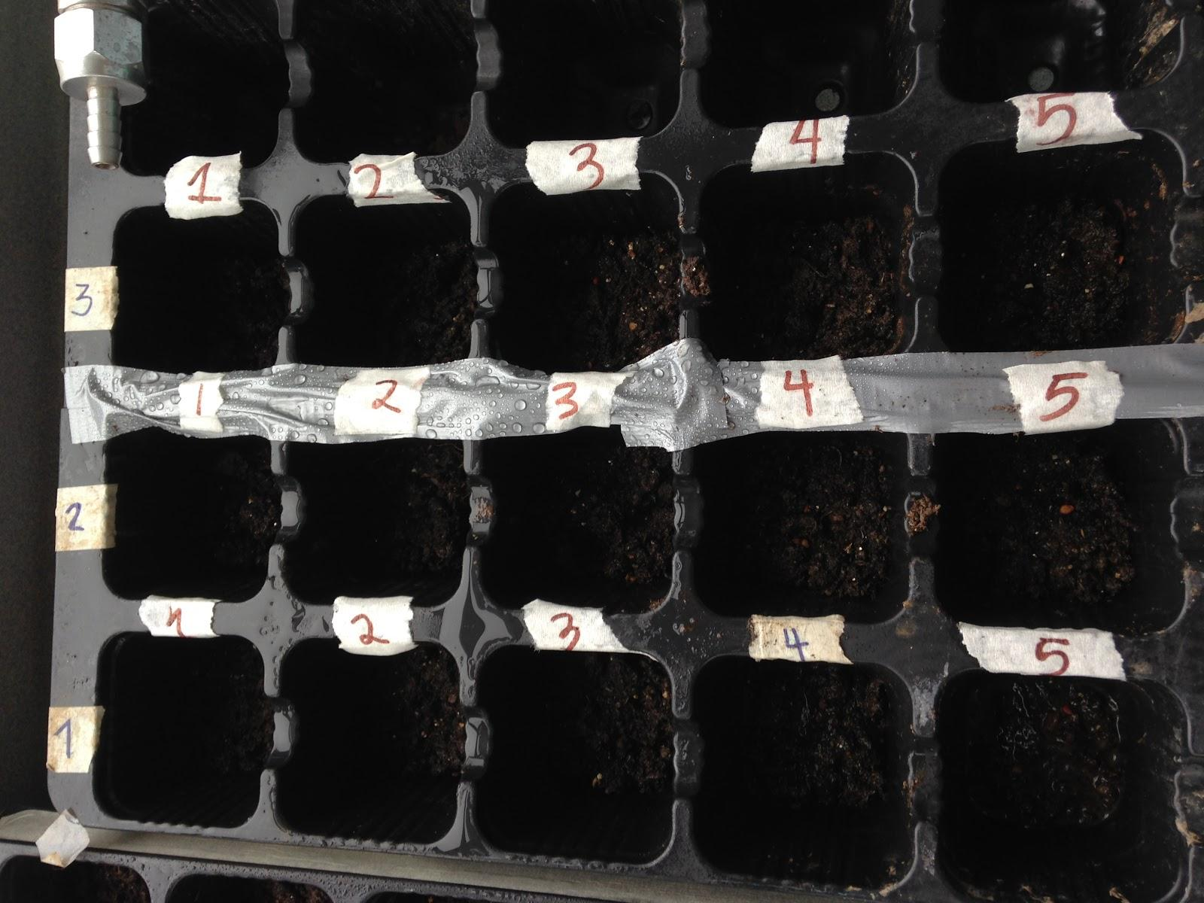
Nov 7 | 1 - 0/5 4 - 0/5  0/5 0/5  0/5 0/5  2 - 0/5 5 – 0/5  0/5 0/5  0/5 0/5  3 - 0/5  0/5  0/5 | Plants have not germinated. No process can be seen yet. Waters were gained sprayed 5 times per hole | 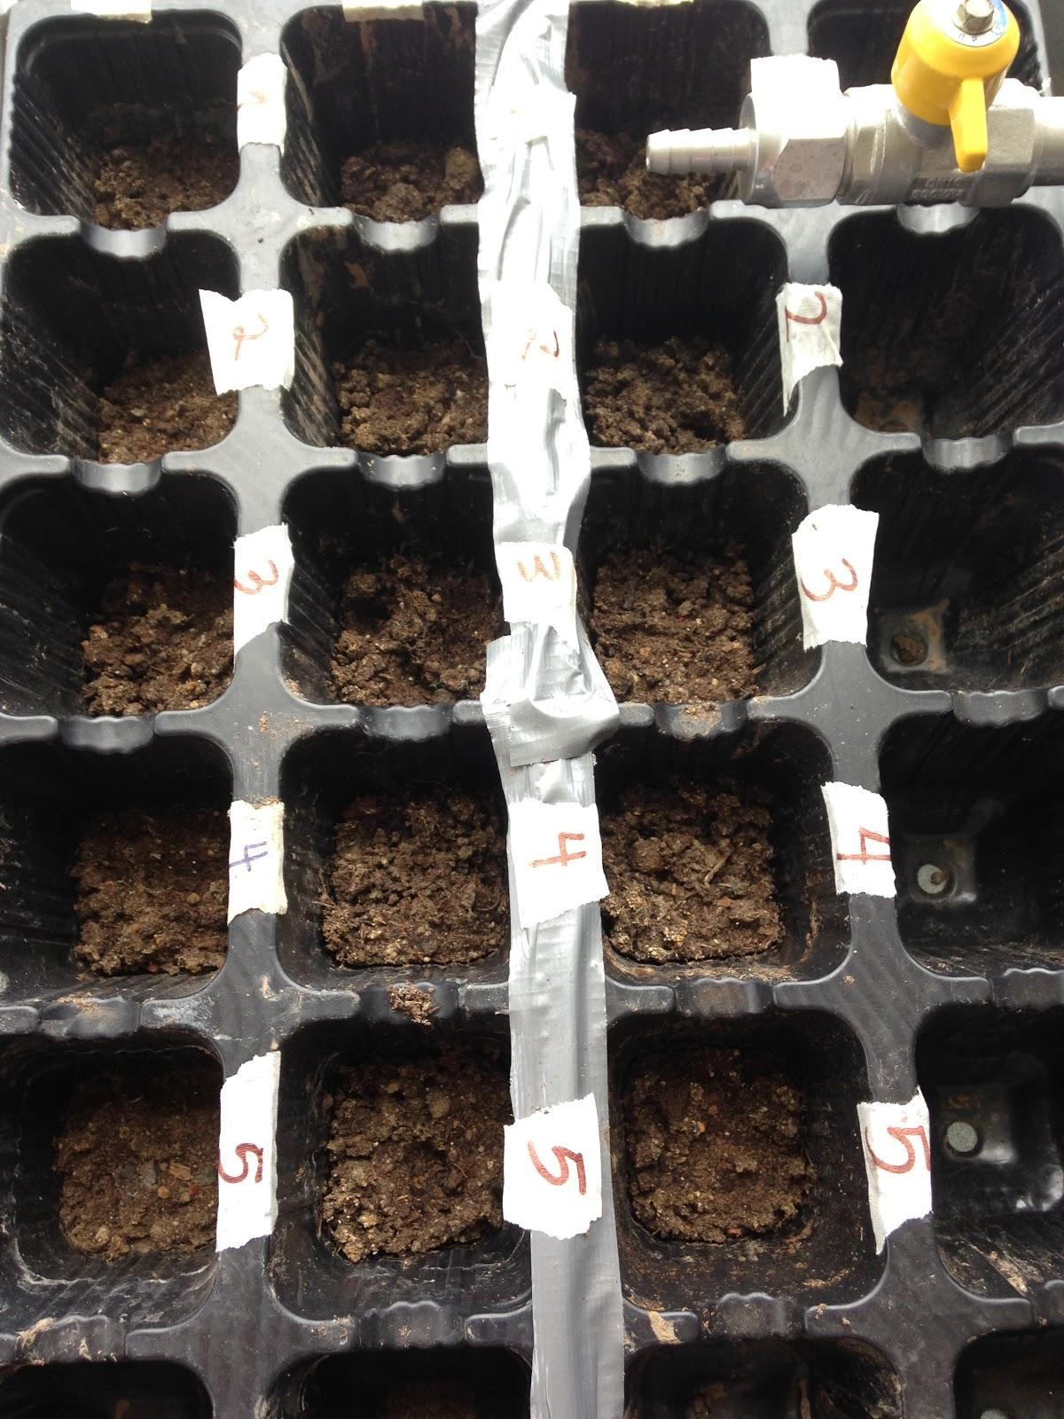
Nov. 11 | 1 - 0/5 4 - 0/5  0/5 0/5  0/5 0/5  2 - 0/5 5 – 0/5  0/5 0/5  0/5 0/5  3 - 0/5  0/5  0/5 | As I got to Mr. Martins room, I noticed that the soil was dry. I watered the plants and noticed that my plants had still not germinated. I knew that I would have to research on the reasons as to why my plants have not germinated. This is because the plants of my rest of my peers had already grown to a relative size where there IV could be introduced in a couple of days, while mine hadn’t- | 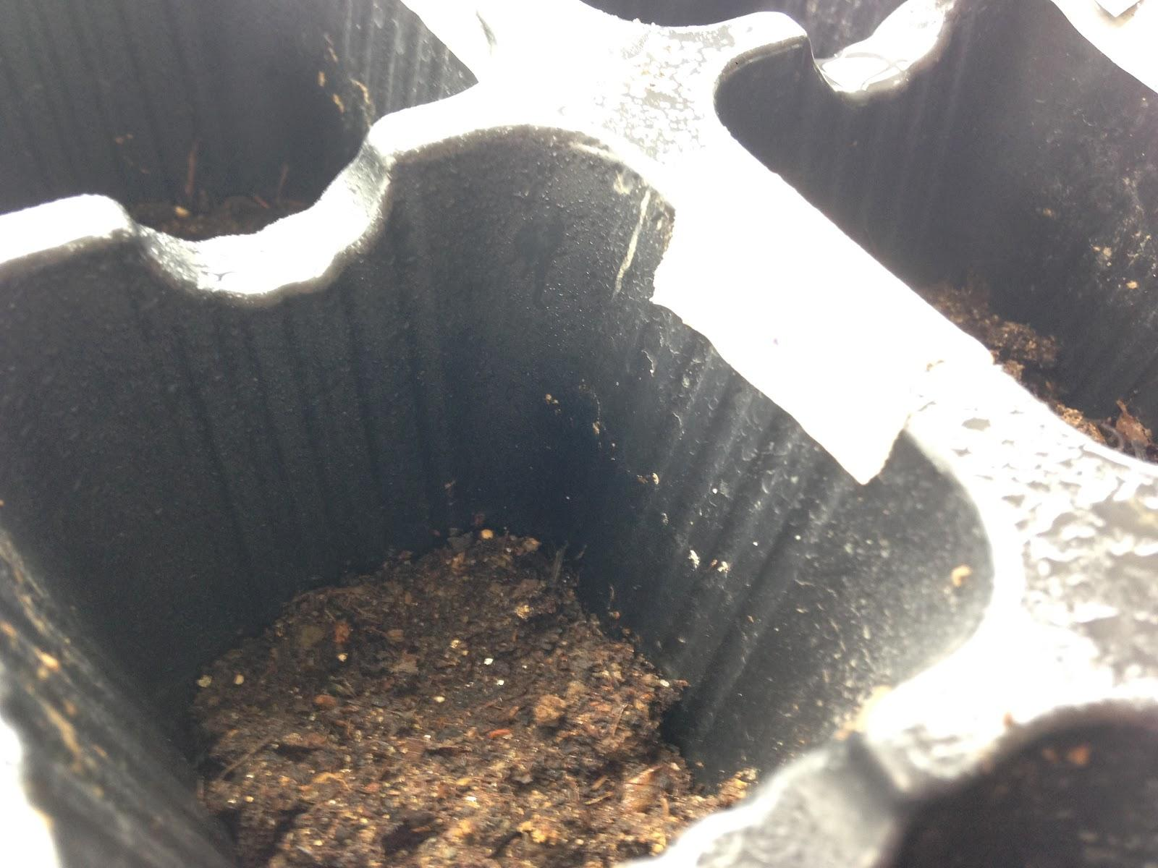
Nov. 14 | N/A | N/A  *plants were watered by Nina :) | N/A
Nov. 18 | 1 - 1/5 4 - 2/5  0/5 0/5  0/5 1/5  2 - 0/5 5 – 2/5  2/5 0/5  1/5 1/5  3 - 1/5  1/5  0/5 | Plants have started to germinate at a slow rate. Plants were watered once again. Next class results of the plants growth will allow me to determinate if its ready for the IV or nor | 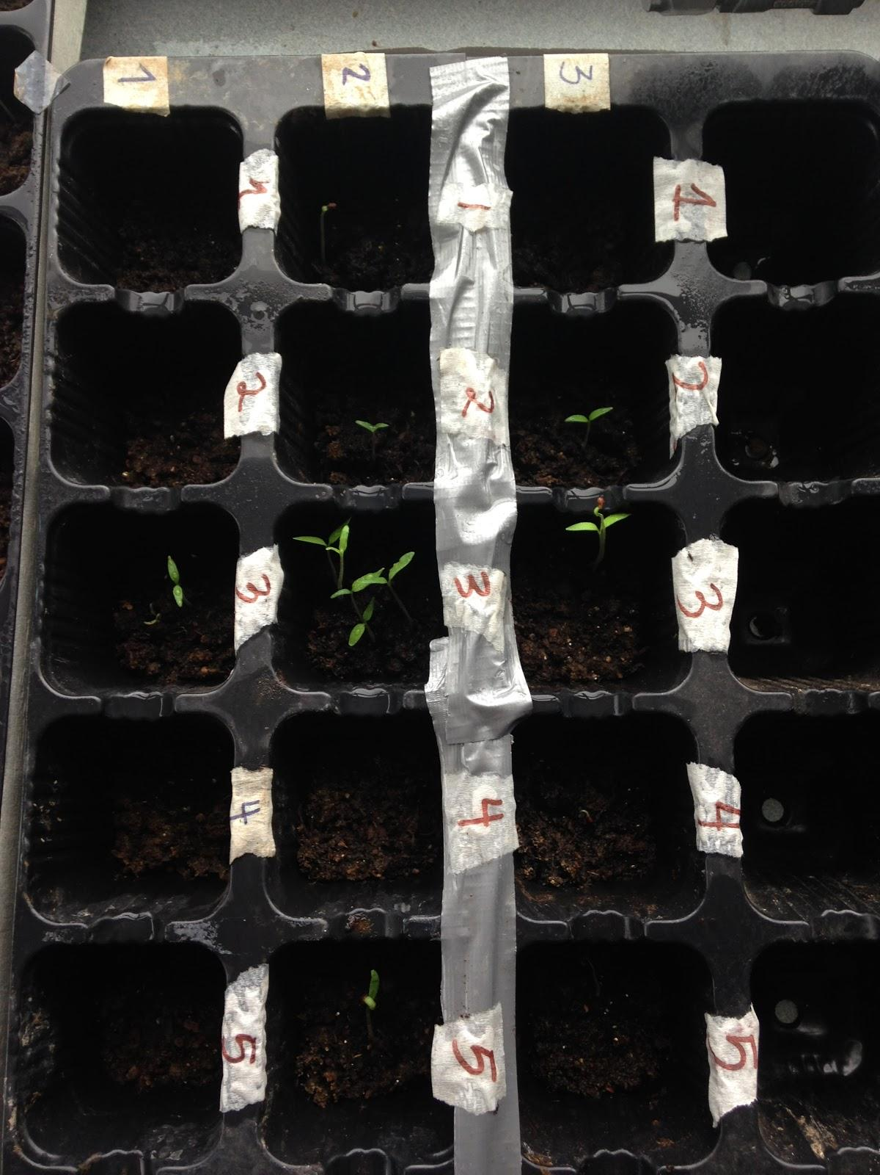
Nov. 20 | 1 - 2/5 4 – 2/5  1/5 0/5  2/5 2/5  2 - 1/5 5 – 1/5  1/5 1/5  4/5 1/5  3 - 2/5  2/5  1/5 | More plants have started to germinate. This results satisfies the procedure in a way where the independent variable will most probable begin to be added next class despite the fact that the plants are still very short. Waters where watered again. | 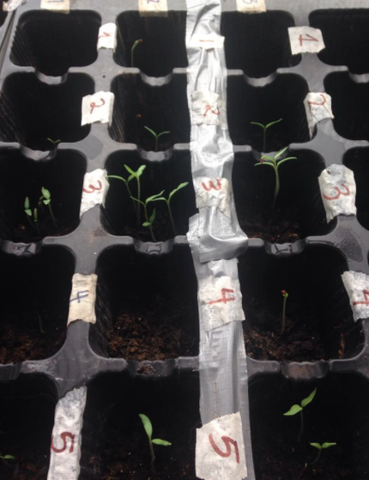
Nov. 25 | 1 - 2/5 4 – 2/5  1/5 0/5  2/5 2/5  2 - 1/5 5 – 1/5  1/5 1/5  4/5 1/5  3 - 2/5  2/5  1/5 | Since no plants grew, I decided to put my IV. 5 droplets of water were placed on set a, 10 on set b and 15 on set c. | NA
Qualitative Data:
Through out this lab I noticed that my plants didn’t fully undergo the process of cellular respiration since it didn’t grow fully. This was because of certain mistakes and errors (Refer to Evaluate Section) through out this lab, which caused a decrease in data collection and reliability. Despite these errors, I was able to work through this lab and learn from my mistakes as well as information which supported the events that occurred.

Data Tables
Raw Data Tables

Processed Data Table
Table 2: The total Amount of Tomato Seeds that Germinated
Test |  | Test 1 | Test 2 | Test 3 | Test 4 | Test 5
Trials | Trial 1 | 2 | 1 | 2 | 2 | 1
 | Trial 2 | 1 | 1 | 2 | 0 | 1
 | Trial 3 | 2 | 4 | 1 | 2 | 1
Total germinated seed |  | 5 | 6 | 5 | 4 | 3
The total number of seeds that germinated per trial is out of 5. Plants were given water and sunlight to develop their growth through a defined period of time.

Table 3: The Biomass of Plants Depending on its Potassium Concentration
Potassium Drops | Number germinated seeds | Avg.  Biomass (g)
0 | 5 | 0.18
5 | 6 | 0.36
10 | 5 | 0.184
15 | 4 | 0.76
20 | 3 | 0.353
All data was collected at Room Temperature (≈23 decrees C) under standardized pressure. Results describe the efficiency that Potassium had on the growth and overall biomass of a plant. All potassium drops where had uncertainties of (mL ±0.01). Biomass was recorded with some soil attached to roots of the plants, giving relative errors.
Graph:

Graph 1:

Graph 2:

Conclusion

By taking a look at the raw data table (table 1), I noticed that ever since the beginning my plants did not germinate. I had introduced 5 tomato seeds to each trail and, due to certain errors along my lab; all seeds did not fully grow. This limited my experiment and the way my results were obtained due to the uncertainty and discrepancy of the amount of plants per trial. Thereby, when looking at Graph 1, we noticed that all plants germinated in similar quantities per trial, proving that it was a scientific error, which didn’t allow the plants to grow, not an error made during the lab by the student. More over, in Graph 1 we are able to see that the plants, which had received 10 drops of potassium, had a biomass of 0.92 g, while the plants, which had received 5 drops of potassium, had an average biomass of 2.16. What was expected to be seen in a graph in relation with the data was an increase on biomass as the potassium level increases, yet our results showed the contrary. This proved that my results and the way the overall lab was performed didn’t give precise results to prove scientific information about how potassium worked as a fertilizer on plants thus improved and made an increase on its biomass.

Discussion

If there is an addition of potassium, then the biomass of the tomato plant will increase because potassium acts as an essential nutrient for a plants growth due to its capability of activating 60 enzymes involved in photosynthesis; it also has the ability of formulating ATP energy used through cellular respiration, a process that is fundamental for a plants growth. My hypothesis, despite it not being supported by my results, was correct.

Potassium (K) is an element that is absorbed by plants in greater amount than any other element and greatly contributes to plants growth. This is because as Potassium activates the plant’s enzymes to undergo photosynthesis, ATP energy is being created as well. This ATP energy is then used as the energy source to break down the glucose produced during photosynthesis and produce aerobic cellular respiration, a process that enables plants growth and reproduction, at a faster rate.

When plants go through the process of cellular respiration, the glucose is being broken down into simple components in order for the plants to receive its necessary nutrients to allow the plants to grow. As potassium was being added to each trial, enzymes that undergo the catalytic reaction in order to break down the glucose present during cellular respiration were being activated. Moreover, the glucose is then formed into ATP energy, a type of energy which will allow greater amount of energy for the plants to grow. On relation, the more potassium per trial, the greater amount of glucose will be broken down at a shorter period of time, causing a faster growth of the plant.

On the other hand, plants that have less amount of Potassium will therefore activate less amount of enzyme, less amount of glucose will be broken down and as a result less amount of ATP energy will be created. The ATP, which acts as essential the most powerful ‘energy carrier’ that can be found in a plants molecule, will make a plant’s growth decrease and decrease its rate. As a result, plants which have less amount of potassium will need to use their stored biomass for respiration (the activation of enzymes and the process of cellular respiration, photosynthesis) thus have less amount of total biomass as the ones with a greater amount of potassium.

Despite Potassium having such benefits on a plants growth and biomass, there needs to be a limit on how much potassium is being added and absorbed by the plants. This is because too much potassium can cause ‘nitrogen deficiency’, a decrease in the most important element of a plant to be able to grow. This is because too much potassium may cause the plant to be ‘overflowed’ by nutrients and interfere with the Nitrogen uptake of the plant, causing it’s overall ability to grow to decrease.

Sorry for this awkward space, Word Tables are not the best.

Evaluate
Weakness/Limitations |  | Impact On Results |  | Improvement
Instead of adding water to the trails in relation with its moisture and amount of humidity, water was added to the trails as a constant variable. The seeds got the same amount of water with out taking in consideration how much water had been absorbed by each trail. | The amount of water that is added to each trial is overflowing the capacity that plants have to absorb water. Thus as the same amount of water was being added to the trail with dry soil as with the wet soil, the plants with the wet soil were undergoing a high level of osmosis, making the plants not allowed to breath. Moreover, as the plants where overwater, the stomata, the plants tiny pores of plants, where blocked and did not allowed the oxygen to diffuse into the plants. |  | If the lab was to be performed again, then a moister probe should be used to test teach trail and the amount of water that it has and avoid this issue.
The seeds inserted in each hole where overcrowded. | By 5 seeds being added to each trial not dispersed enough within the space given, then the plants where not able to spread their roots when germinating. This caused several impacts such as: the sunlight not being able to filter to the lower leaves, the moisture not reaching the soil and provide necessary nutrients to the plants. (1) |  | Make sure that every time a seed is inserted to the trail, it is well dispersed from the previous tomato seed, which was inserted. Since 5 seeds are being added to one hole, then there can be one seed per corner and the one in the middle. This will allow a greater diversity of distribution between each seed.
The correct season was not chosen to grow Tomato Plant. This is because these seeds are to be grown best 6-8 weeks before the spring breaks with an average temperature of 20 C. (2) | The altering temperatures that we faced through out this lab caused the plants to decrease its pollination process since the optimum temperature in which the enzymes reacted to in photosynthesis was incorrect. |  | The temperature through out the experiment was measured daily in order to record information and be able to reflect the results in relation with the temperature.  Another way in which the temperature can be controlled is by using a waterproof seedling mat with a thermostat.
Un precise drops of Potassium added | Because I was measuring the effects that Potassium had on plants, it was very important to be precise on the amount added. The uncertainty that the drops had caused our data to be not as reliable and precise. |  | Instead of using a dropper, measure the amount of Potassium (or IV) being added with a beaker.

Appendixes

Appendix A: A representation of how the trays will be arranged when performing this lab. The IV will vary 5 times where 3 trials will be made per each change in IV.

1-1 | 1-2 | 1-3
2-1 | 2-2 | 2-3
3-1 | 3-2 | 3-3
4-1 | 4-2 | 4-3
5-1 | 5-2 | 5-3

Work Cited
- "What Happens When Plants Get Too Much Potassium?" EHow. Demand Media, 10 Nov. 2009. Web. 06 Dec. 2014.
- "Hot Weather And How It Effects Your Garden." Hot Weather and How It Affects Gardens. N.p., n.d. Web. 06 Dec. 2014.
"Action Mode, Deficiency & Toxicity of the 17 Essential Nutrients." Action Mode, Deficiency & Toxicity of the 17 Essential Nutrients. N.p., n.d. Web. 06 Dec. 2014.
"The Effects of Water PH on Plant Growth." GardenGuides. N.p., n.d. Web. 06 Dec. 2014.
Pumpkin Production. University Park, PA: PennState College of Agricultural Sciences, Cooperative Extension, 1995. Web.
"What Happens When Plants Have Too Much Water?" EHow. Demand Media, 28 Feb. 2011. Web. 06 Dec. 2014.
"Potassium in Plants." And Soil. N.p., n.d. Web. 06 Dec. 2014.
"Potassium for Crop Production." : : Nutrient Management: University of Minnesota Extension. N.p., n.d. Web. 06 Dec. 2014.

